Algebra 2, Unit 8 - Exponents #14

Day 14: Review of Exponents
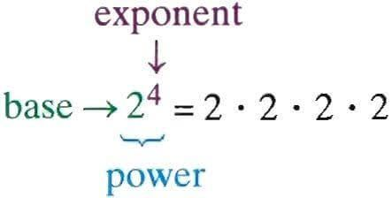

Re-write each problem using exponents. For example, 8 x 8 x 8 can be rewritten as 8³. You do NOT need to evaluate (find the value of).
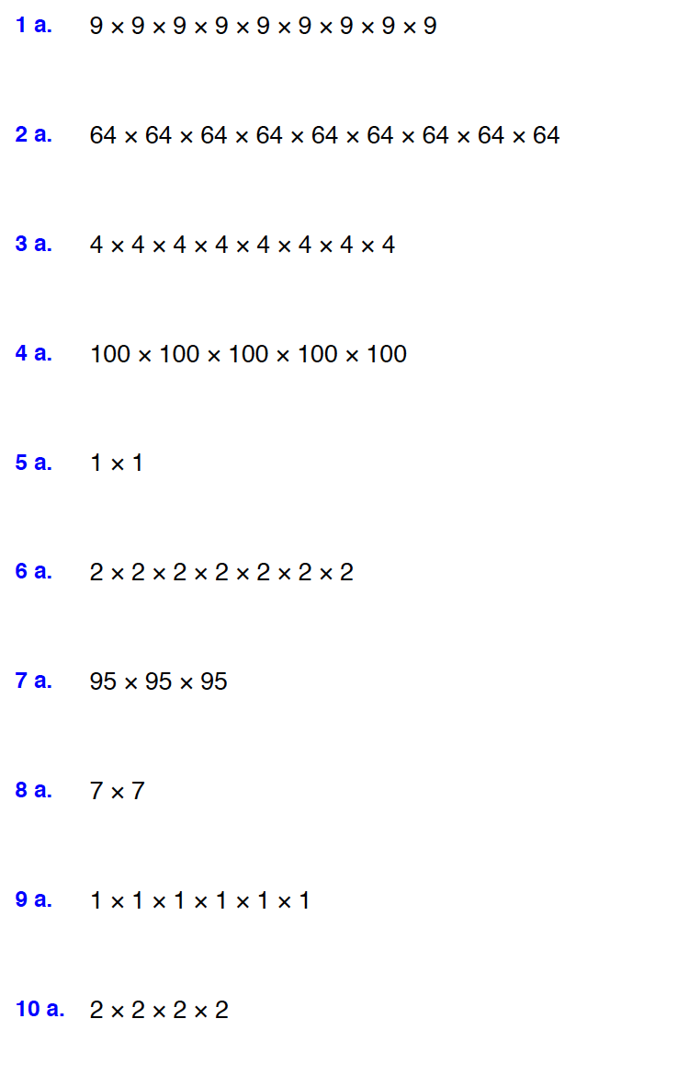

Find the value of each problem. For example, 5² has a value of 25.

