Algebra 2, Unit 8: Exponential Functions #16
Day 16: The King’s Daughter
EXPONENTIAL FUNCTIONS

Today, you will explore exponential growth. You will also compare exponential growth with linear growth. Finally, you will explore exponential patterns in tables, graphs and equations. (sound familiar?)

THE SCENARIO: One day, in the ancient kingdom of Montarek, a peasant saved the life of the king’s daughter. The king was so grateful he told the peasant she could have any reward she desired. The peasant - who also was the kingdom’s chess champion - made the following unusual request.
“I would like you to place 1 ruba on the first square of my chessboard, 2 rubas on the second square, 4 on the third square, 8 on the fourth square, and so on, until you have covered all 64 squares. Each square should have twice as many rubas as the previous square.”

The king replied, “Rubas are the least valuable coin in the kingdom. Surely you can think of a better reward!” But the peasant insisted, so the king agreed to her request. Let’s see if the peasant made a wise choice!

TASKS:

- On the given board squares, stack coins on top of each other that represent the number of rubas the king will give the peasant.

- If you were to graph this, make a quick sketch below of what you think the graph would look like:

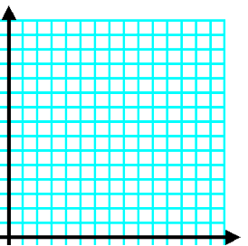

# of Rubas

# of Squares

- Look at the table below. Fill in all boxes to show the number of rubas the king will place on squares 1 through 10 of the chessboard.

# squares | # rubas  (standard representation) | exponential  representation | expanded representation
1 | 1 | 2⁰ | -
2 | 2 | 2¹ | 2
3 | 4 | 2² | $2∙2$
4
5
6
7
8
9
10

3. How does the number of rubas change from one square to the next?

4. Graph the data for squares 1 through 7 below. You might need to adjust the scale on the axes.

# of Rubas

# of Squares

5. How is this graph different from the graphs from semester 1?

6. Write an equation for the relationship between the number of the square (x) and the number of rubas (y). If you can’t figure this out now, leave it and answer the other questions.

7. Describe the graph in words. How does the y-value change as x increases over time? How does this change show up in the equation?

8. Which square will have 2³⁰ rubas? (Careful!)

9. What is the first square on which the king will place at least one million rubas? How many rubas will there be on that particular square?

10. How many rubas will there be on square number 30? Show work. Don’t extend the table, but rather use the equation you wrote in #6.

Linear vs Exponential Practice:

Each of the following situations is linear or exponential. Identify which type of pattern fits each situation. Then, identify the start value and the consistent growth rate/factor.

Equations:
Equations | $y=\frac{3}{5}x-5$ | $y=\frac{3}{5}(2)^{x}$ | $y=564(\frac{2}{3})^{x}$ | $y=564-\frac{2}{3}x$
Linear or Exponential?
Start value?
Growth rate/factor?

Graphs:
Graphs | 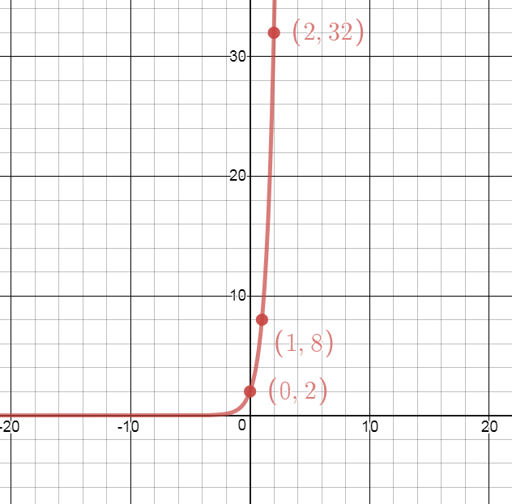 | 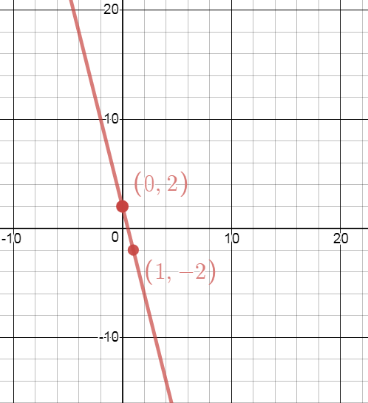
Linear or Exponential?
Start value?
Growth rate/factor?

Tables:
Tables: | x 0 1 2  y 10 20 30 | x 0 1 2  y 10 20 40
Linear or Exponential?
Start value?
Growth rate/factor?

