Algebra 2, Unit 8: Exponent Properties WS#19
Day 19: Positive Exponent Properties

Product of Powers Property
Complete the table.
Expression | Expression as repeated multiplication | Number of factors | Simplified expression
7⁴ • 7⁵ | 7 • 7 • 7 • 7 • 7 • 7 • 7 • 7 • 7 | 9 | 7 ⁹
(–4)² • (–4)³
x¹ • x⁵

Product of Powers Rule:

xª • x^{b} =

Power of a Power Property
Complete the table.
Expression | Expanded expression | Expression as repeated multiplication | Number of factors | Simplified expression
(5³)²
[(–6)²]⁴
(a³)³

Power of a Power Rule:

(xª)^{b} =

Practice

Simplify the expression. Write your answer using exponents.
 | 1. 5² • 5³ | 2. (–6)¹ • (–6)⁴ | 3. m⁶ • m⁴
 | 4. (10³)³ | 5. [(–2)³]⁴ | 6. (c²)⁶

Power of a Product Rule: (xªx^{b})^{m} =

Quotient of Powers Property
Complete the table.
Expression | Expression as repeated multiplication | Simplified expression | Simplified expression as a power
$\frac{2^{7}}{2^{3}}$ | $\frac{2⋅2⋅2⋅2⋅2⋅2⋅2}{2⋅2⋅2}$ | $2⋅2⋅2⋅2$
$\frac{2^{5}}{2^{3}}$
$\frac{2^{4}}{2^{1}}$
$\frac{5^{6}}{5^{3}}$
$\frac{4^{3}}{4^{1}}$
$\frac{{(-3)}^{3}}{{(-3)}^{2}}$

Quotient of Powers Rule:

$\frac{x^{ a}}{x^{ b}}=$

Practice

Simplify the expression. Write your answer using exponents.

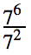
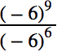
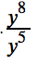
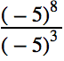
1. 2. 3. 4. 5.

Power of a Quotient Property
Complete the table.
Expression | Expanded expression | Product of fractions | Product as a quotient of powers
${\left(\frac{5}{8}\right)}^{3}$ | $\frac{5}{8}⋅\frac{5}{8}⋅\frac{5}{8}$ | $\frac{5⋅5⋅5}{8⋅8⋅8}$ | $\frac{5^{3}}{8^{3}}$
${\left(\frac{4}{7}\right)}^{5}$
${\left(\frac{1}{2}\right)}^{4}$
${\left(\frac{3}{5}\right)}^{3}$
${\left(-\frac{2}{3}\right)}^{2}$

Power of a Quotient Rule:

${\left(\frac{x}{y}\right)}^{a}=$

Practice

Simplify the expression. Write your answer using exponents.

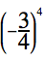
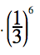
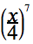
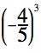
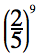
1. 2. 3. 4. 5.

Practice: Positive Exponent Properties

Write the Rules from the boxes on the previous pages:

Product of Powers: ___________________________
Power of a Power: ___________________________
Power of a Product: ___________________________
Quotient of Powers: ___________________________
Power of a Quotient: ___________________________

Product of Powers PRACTICE: Simplify the expression.
1. 3²$⋅$ 3⁷ 2. 5⁴ $⋅$ 5⁹ 3. (-7)² $⋅$(-7) 4. x² $⋅$ x⁶ $⋅$ x

Power of a Power PRACTICE: Simplify the expression.
5. (4²)⁷ 6. [(-2)⁴]⁵ 7. (n³)⁶ 8. [(m+1)⁵]⁴

Power of a Product PRACTICE: Simplify the expression.
9. (x$⋅$ y)² 10. (-3n)² 11. (9m³n)⁴ 12. 5x$⋅$(5x²)⁴

Quotient of Powers PRACTICE: Simplify the expression.

Power of a Quotient PRACTICE: Simplify the expression.
15. ${\left(\frac{2x}{3y}\right)}^{3}$ 16. $\frac{m^{3}}{n^{5}}⋅{\left(\frac{m^{4}}{n^{2}}\right)}^{3}$

Combined PRACTICE:
Simplify the following expression. Only the variables should have exponents. Compute any bases with actual numbers!

18. (-5x)² 19. –(7xy²)² 20. (3x⁵)(2x⁷)²

Algebra 2,Unit 8: Exponent Properties #20

Day 20: Exploring Zero and Negative Exponents

Complete the table below.

Expression | Value (written as a whole number or fraction)
2⁴
2³
2²
2¹
2⁰
2⁻¹
2⁻²
2⁻³
2⁻⁴

Zero Exponents:

x⁰ =

Negative Exponents:

x^{-a} =

Examples:

1. $x^{-2}⋅x^{5}$ 2. $4^{8}⋅4^{-3}$

3. ${3xy^{3}y^{-7}}^{}$ 4. ${12ab^{5}b^{-11}}^{}$

Practice: Negative and Zero Exponent Properties

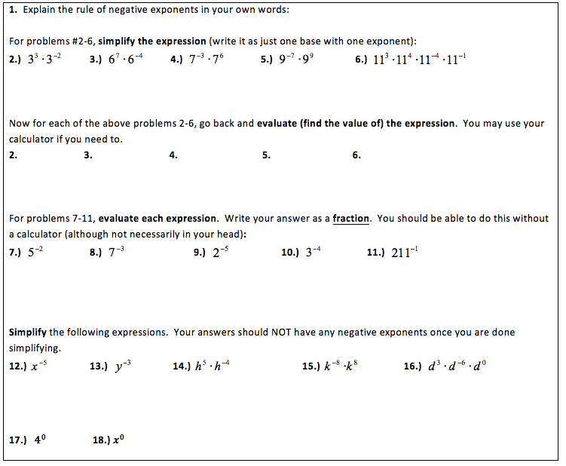

MORE Exponent Examples and Practice

Combining Positive Properties
Example 1: Example 2:

Combining Negative Properties
Example 1: Example 2:

You Try:
1. (3x⁴y⁵)(2x³)² 2. $\frac{8a^{5}b^{-5}}{2a^{-2}b{}^{}}$

Review
