AA Unit 2: Graphs and their transformations
I can sketch the parent graph of a:  - Linear Function $y=x$  - Quadratic Function $y=x^{2}$  - Cubic Function $y=x^{3}$  - Square Root Function $y=\sqrt{x}$  - Cube Root Function $y=\sqrt[3]{x}$  - Absolute Value Functions $y=|x|$  - Rational Functions $y=\frac{1}{x}$ | 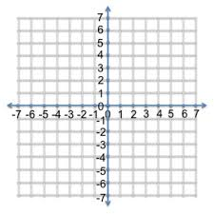
I can graph and analyze
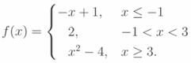
- Piecewise Functions

- Step Functions
$y= 0, -1≤x≤0$
$1, 0<x≤1$
$2, 1<x≤2$
$3, 2<x≤3$
...
I can graph and describe transformation of functions
- Horizontal and Vertical Translations
  - $y=f(x)+k$

  - $y=f(x+h)$

- Horizontal and Vertical Dilations (stretch or compress)
  - $y=af(x)$

  - $y=f(bx)$

- Horizontal and Vertical Reflections
  - $y= -f(x)$

  - $y=f(-x)$

I can Complete the Square to write a Quadratic Function in Graphing form.
- Write the function $p(x)=ax^{2}+bx+c$ in graphing form and describe the transformations used to change the parent function $y=x^{2}$ to $p(x)$.

- Model quadratic situations using Graphing Form.

