AA Unit 3: Inverses Notes
I can find the INVERSE of a function algebraically.  The first step to finding the inverse of  $h(x)=\sqrt{2x+1}+5$ is to switch the ____  and the _____ to form the equation  _____________  Then solve this equation for ______ by  Reversing Operations. | I can find the INVERSE from a given table.  The table representing the inverse $f^{-1}(x)$ can be  created by ______________________________  ________________________________________.  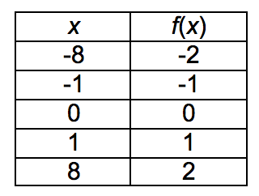
I can graph the INVERSE from a given graph.  To draw the INVERSE, I locate ___________ on the  original graph and switch the ____ and the _____ and  graph these new points.  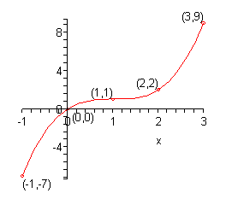 | I can use a graph to determine whether or not a RELATION is a FUNCTION.  The ______________ Line Test shows that a  RELATION is a function if any ____________ line  hits the graph in AT MOST ________ point.  The ______________ Line Test shows that a  RELATION is NOT a function if any __________ line  hits the graph in MORE THAN ________ point.  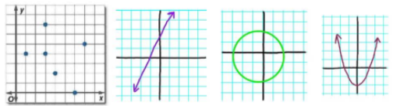
I can use a table to determine whether or not a RELATION is a FUNCTION.  If a table has repeated ____ values that have different.  ____ values then the table ____________________  ___________________  If each _____ value in a table has only one ______  value then the table _________________________  ____________  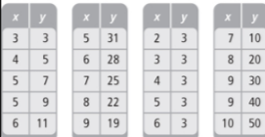 | I can use COMPOSITE FUNCTIONS to determine whether on not two functions are INVERSES.  $f(x)=2\sqrt{x-1}+2$ and $g(x)=(\frac{x-2}{2})^{2}+1$  The COMPOSITE FUNCTION $f(g(x))$ means you  replace the x in _________ with ______________  If two functions are INVERSES then $f(g(x))$  simplifies to ________. This makes sense because  if two functions are INVERSES, combining the two  functions should ___________________________  _________________________________________.

