Algebra 2,Unit 8: Exponent Properties #20

Day 20: Exploring Zero and Negative Exponents

Complete the table below.

Expression | Value (written as a whole number or fraction)
2⁴
2³
2²
2¹
2⁰
2⁻¹
2⁻²
2⁻³
2⁻⁴

Zero Exponents:

x⁰ =

Negative Exponents:

x^{-a} =

Examples:

1. $x^{-2}⋅x^{5}$ 2. $4^{8}⋅4^{-3}$

3. ${3xy^{3}y^{-7}}^{}$ 4. ${12ab^{5}b^{-11}}^{}$

Practice: Negative and Zero Exponent Properties

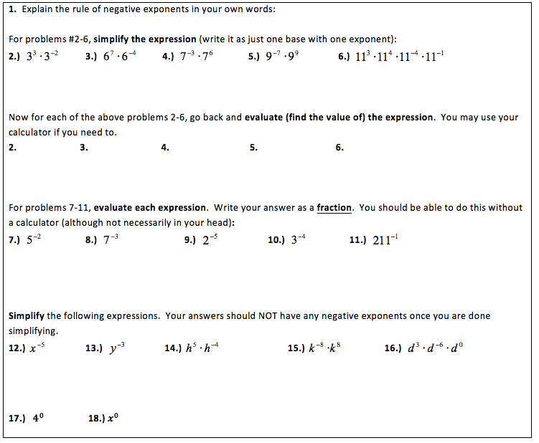

MORE Exponent Examples and Practice

Combining Positive Properties
Example 1: Example 2:

Combining Negative Properties
Example 1: Example 2:

You Try:
1. (3x⁴y⁵)(2x³)² 2. $\frac{8a^{5}b^{-5}}{2a^{-2}b{}^{}}$

Review
