Algebra 2, Unit 8 #22
Day 22: Review
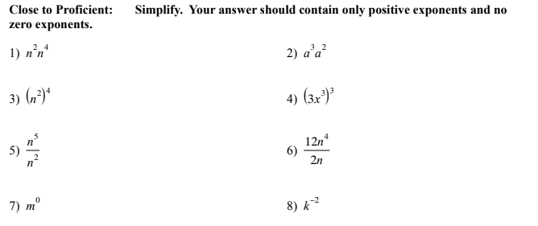

Proficient and Highly Proficient: Simplify. Your answer should contain only positive whole number exponents, and no zero exponents.
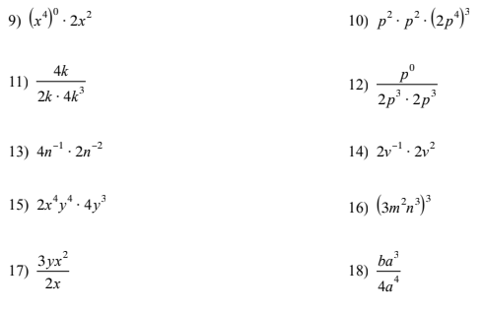
19) $9^{\frac{1}{2}}$ 20) ${16}^{\frac{3}{4}}$ 21) ${(x^{6})}^{\frac{1}{2}}$

Exponential Functions
Close to Proficient: Make a table and graph the exponential equation $y=4⋅2^{x}$
- Table  x $y=4⋅2^{x}$  0  1  2  3  b. Is this exponential growth or decay? Explain | c. Graph $y=4⋅2^{x}$. Label your axes.  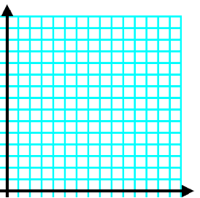
Proficient/ Highly Proficient:
Write an equation of this graph.  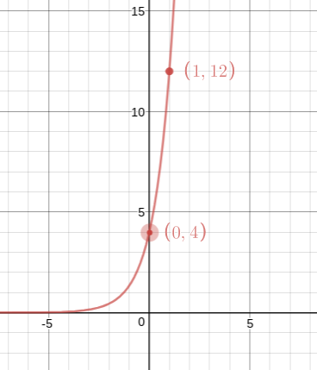  y = _____________________________ | Write an equation for this table.  x y  0 64  1 48  2 36  3 27  y = __________________________  Check that your equation works:

