Algebra 2, Unit 9: Quadratics #25b
Day 25: Linear vs. Exponential vs. Quadratic

Look closely at these TABLES. Describe any patterns you notice.
These have a linear relationship:  Describe patterns: | These have an exponential relationship:  Describe patterns:
These have a quadratic relationship: | Explain how you can identify if a relationship is linear, exponential, or linear from a table of values?

Look closely at these GRAPHS.
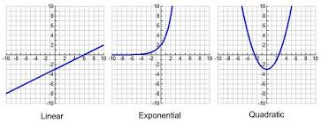

Explain how you can tell if a graph is linear, exponential, or quadratic.

Equations
These are linear equations:  y = $-\frac{1}{2}x+8$  2x + 3y = -15  x = 5 | These are exponential equations:  $y=3^{x}$  $y=4⋅{(0.8)}^{x}$  $y=7({\frac{3}{2}}_{})^{x}+2$ | These are quadratic equations:  $y=x^{2}$  $y=2x^{2}-4x+6$  $f(x)=3(x-4)^{2}+7$
Explain how you can tell if an equation is linear, exponential, or quadratic.

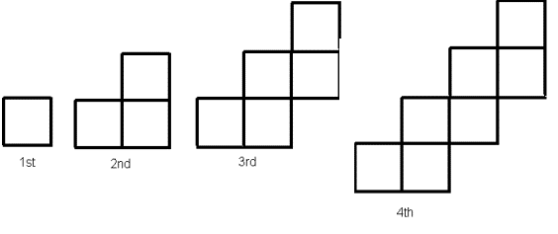
Look closely at TILE PATTERNS. Figure out which is linear, exponential, and quadratic.
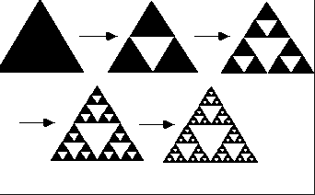

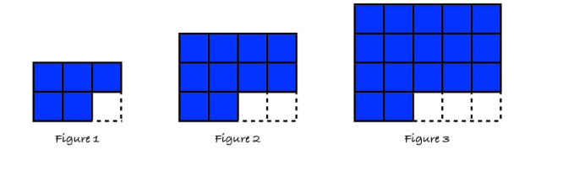

Explain how you can tell if a TILE PATTERN is linear, exponential, or quadratic.

Bonus: Write a rule for each pattern. Describe what the variables in your rule stand for.

Spicy Bonus: Which pattern will exceed 10,000 first? How do you know? What about last?

