Algebra ½ Name:____________

Day 26: Squared Quadratics

Without counting one by one, how many tiles are there in this square?  How many of those tiles are border tiles?  How many of those tiles are interior tiles? | 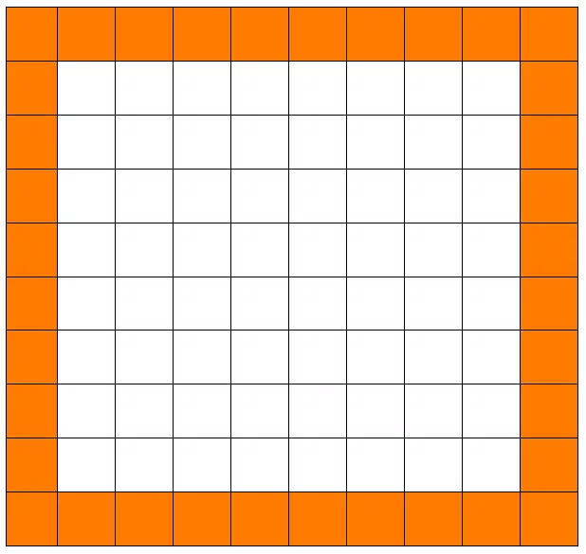
In the box to the right, draw a square that has 36 tiles total (border AND interior).

How many of the 36 tiles are border tiles?

How many are interior tiles?
In the box to the right, draw a square that has 4 tiles total (border AND interior).

How many of the 4 tiles are border tiles?

How many are interior tiles?

Describe any connections you have found. Think about how the number of border tiles relates to the number of total tiles or to the number of interior tiles.

Fill in the blanks to make each sentence TRUE:
If my square has 4 tiles on each side, then it has ____________ tiles total (Interior AND border).

If my square has _____ tiles on each side, then it has 49 tiles total (Interior AND border).

If my square has 36 total tiles, then it has ________ interior tiles and ________ border tiles

If my square has ______ total tiles, then it has 36 interior tiles and _________ border tiles

If my square has ______ total tiles, then it has _____ interior tiles and 20 border tiles

Now we are going to try to generalize what we have found. Use the picture below as a guide.

The interior square is “x” units on each side. The border is 1 unit wide.

How many interior tiles are there?
The border has 4 sides. Each side is a little bit LONGER than x.  How many border tiles are there? | The outer square has 4 sides. Each side is a little bit LONGER than x.  How much longer is each side of the outer square than the inner square?  How many total tiles are there?

Remember that TOTAL = INTERIOR + BORDER. Use your answers to write an equation in terms of “x”.

On the previous page you should have found that: $(x+2)^{2}=x^{2}+4x+4$ because the outer square is TWO units bigger than the inner square, and the outer square is made up of the inner square PLUS 4 sides PLUS 4 corners.

Please notice that $(x+2)^{2}≠x^{2}+2^{2}$. This is simply NOT how squares work.

Squared Quadratics Continued
Imagine you want to put ANOTHER border around the square. This is in addition to the border you already see.

How many more tiles do you need to add?

How many TOTAL tiles are there?

How many DOUBLE BORDER tiles are there?
In the box to the right, draw a square that has 36 tiles with a DOUBLE BORDER (border AND interior).

How many of the 36 tiles are border tiles?

How many are interior tiles?
In the box to the right, draw a square that has 16 tiles with a DOUBLE BORDER (border AND interior).

How many of the 16 tiles are border tiles?

How many are interior tiles?

Describe any connections you have found. Think about how the number of border tiles relates to the number of total tiles or to the number of interior tiles.

Now we are going to try to generalize what we have found. Use the picture below as a guide.

The interior square is “x” units on each side. Remember that this has a DOUBLE BORDER.

How many interior tiles are there?
The DOUBLE BORDER has 4 sides. Each side is a little bit LONGER than x.  How many border tiles are there? | The outer square has 4 sides. Each side is a little bit LONGER than x.  How much longer is each side of the outer square than the inner square?  How many total tiles are there?

Remember that TOTAL = INTERIOR + BORDER. Use your answers to write an equation in terms of “x”.

Squared Binomials
The following equations are all TRUE. Explain how the numbers on the left side of each equation relate to the numbers on the right side. One is done for you as an example.
$(x+2)^{2}=x^{2}+4x+4$
$(x+4)^{2}=x^{2}+8x+16$
$(x+6)^{2}=x^{2}+12x+36$ | $6⋅2=12 and 6^{2}=36$
$(x+8)^{2}=x^{2}+16x+64$

You try: Use your patterns from the previous problem to complete each equation.
- $(x+5)^{2}=x^{2}+ +$
- $(x+1)^{2}=x^{2}+ +$
- $(x+ )^{2}=x^{2}+6x+9$
- $(x-3)^{2}=$
- $(x )^{2}=x^{2}-20x+100$

