Algebra 2 Name:___________

Completing the Square

What makes a square?
- Explain using words and pictures why the following statement is TRUE: Every square is a rectangle, but not every rectangle is a square. In other words, many rectangles are NOT squares.

- Explain using words and pictures why the following statements are true:
  - $\sqrt{4}=2$

  - $\sqrt{49}=7$

  - $\sqrt{1}=1$

- The numbers 4, 49, and 1 are examples of PERFECT SQUARES because they can be drawn as squares with whole number side lengths. In other words, $4=2^{2}$, $49=7^{2}$, and $1=1^{2}$. Most numbers are not perfect squares. Classify the following numbers into perfect squares and not perfect squares: $24, 25, 26, 36, 37, 63, 64, 80, 81, 99, 100, 400$

Perfect Squares | Not Perfect Squares
(Slightly spicy)
- Mr. Maurer claims that ALL numbers are rectangles but not all numbers are squares. In other words, many numbers are not squares (but are still rectangles). Use words and pictures to explain why his statement is true.

What makes a Quadratic Equation a Perfect Square?
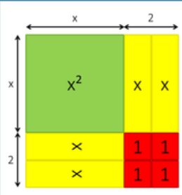
- Please keep in mind that the word “square” has two equivalent meanings: A number times itself, and a 4-sided shape with equal sides. This is crucial to understanding the process of COMPLETING THE SQUARE. Explain why the following equations are TRUE using the picture below:

$(x+2)^{2}=x^{2}+4x+4$

$\sqrt{x^{2}+4x+4}=x+2$

- Write two equations for each picture below using the previous question as an example.
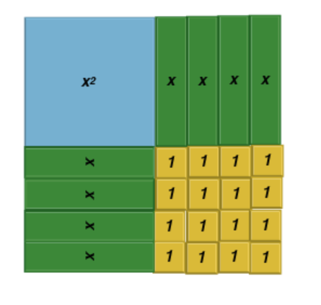 | 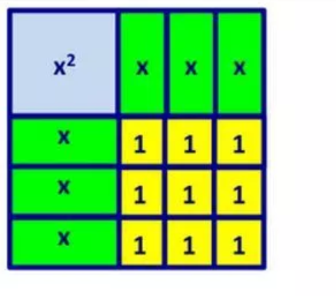 | 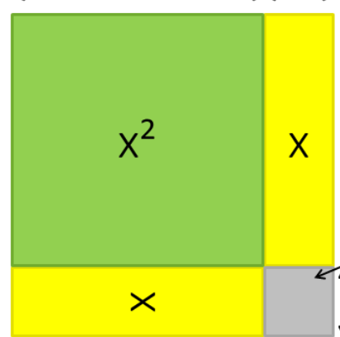
- Is there a way to connect the two expressions WITHOUT drawing a square? In other words, is there a shortcut to get from $x^{2}+4x+4$ to $(x+2)^{2}$ just by looking at the numbers? Your shortcut should also explain how to get from $x^{2}+6x+9$ to $(x+3)^{2}$
- Here are a few more examples of expressions in the OUTSIDE version and the INSIDE version. Match each OUTSIDE to the corresponding INSIDE.

OUTSIDE | INSIDE
$(x+6)^{2}$ | $x^{2}+14x+49$
$(x+10)^{2}$ | $x^{2}+20x+100$
$(x+7)^{2}$ | $x^{2}-6x+9$
$(x-3)^{2}$ | $x^{2}+12x+36$

COMPLETING THE SQUARE
- Most integers aren’t perfect squares, but every integer can be written as a perfect square PLUS some leftovers. For example, $12=3^{2}+3, 17=4^{2}+1, 0= 1^{2}+(-1)$. Express the following integers as a perfect square PLUS some leftovers:
$7=$ $10=$ $27=$ $38=$ $-3=$

- Similarly, most quadratic expressions aren’t perfect squares, but every quadratic expression can be written as a perfect square PLUS some leftovers.
The picture at the right explains why $x^{2}+6x+11=(x+3)^{2}+2$  - Which part of the equation represents the INSIDE? Explain how you know. | 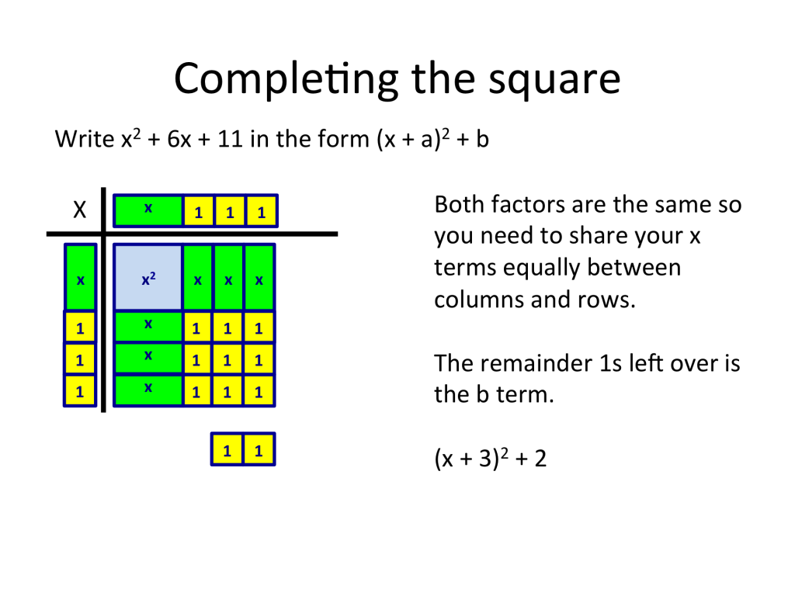

Here are a few more example of equations representing the INSIDE and OUTSIDE
$x^{2}+4x+7=(x+2)^{2}+3$ $(x+3)^{2}+1=x^{2}+6x+10$ $x^{2}+10x+27=(x+5)^{2}+2$

Explain how the numbers in the INSIDE version relate to the OUTSIDE version.

Use the pattern you just discovered to fill in the blanks in the following INSIDE-OUTSIDE equations.

INSIDE | OUTSIDE
$x^{2}+4x+5$ | $(x+2)^{2}+$
$x^{2}+8x+$ | $(x+ )^{2}+1$
$x^{2}+10x+26$ | $(x+ )^{2}+$
$x^{2}+ +$ | $(x+{3)^{2}+5}^{}$

Mixed Practice: Complete the square on the following quadratic expressions in standard form. Check your answers.

- $x^{2}+2x+3$

- $x^{2}+2x+5$

- $x^{2}+2x+55$

- $x^{2}+10x+55$

- $x^{2}-2x+3$

- $x^{2}-2x+5$

- $x^{2}-2x-3$

