Algebra 2, Unit 9: Quadratics #27a
Day #27a: Graphing and IDing Characteristics of Vertex Form

A quadratic function is a function that’s largest exponent is ______ .

The graph of a quadratic function is a U-shaped graph called a _____________________.

The ___________________________________ for the family of quadratic functions is y = x².

Vertex: _________________________________________________________________________________

Axis of Symmetry: ________________________________________________________________________

Minimum or Maximum Value ______________________________________________________________

Graph the quadratic functions on the same graph. We will always graph quadratics using FIVE points.

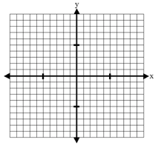
- y = x²

Vertex: ____________ A.O.S. _____________ Does this graph have a minimum or
maximum point?

- y = -x²

Vertex: ____________ A.O.S. _____________ Does this graph have a minimum or
maximum point?
- y = (x - 2)² + 3

Vertex: ____________ A.O.S. _____________ Does this graph have a minimum or
maximum point?

- y = -(x + 3)² + 5

Vertex: ____________ A.O.S. _____________ Does this graph have a minimum or
maximum point?
5. y = -2(x + 3)² + 5

Vertex: ____________ A.O.S. _____________ Does this graph have a minimum or
maximum point?

Summarize by looking at your work on p.1-2
- How can you know by just looking at an equation if a quadratic will have a minimum or maximum point?

- How can you know by just looking at an equation what the vertex is?

- How can you know by just looking at an equation what the axis of symmetry is?

VERTEX FORM:

- Remember from WS#24 when DeAndre and Bree were kicking a football and it could be modeled by the function y = -16(x - 2)² + 64.

  - What is the vertex? ( ____, ____ )

  - What is the axis of symmetry? __________

  - Will it have a minimum or maximum?

  - Now figure out what values for x should go in the table so you have two numbers on either side of the vertex, and make the table. Then, graph the function. Make sure to label your axes with numbers.
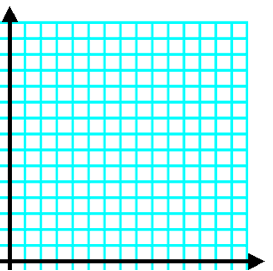

- How would the graph of y = (x - 2)² + 3 be affected if the function were changed to y = -(x - 2)² + 4?

Solving Practice

Solve each equation.
1. x² = 25 | 2. (x + 3)² = 25
3. (x + 3)² - 14 = 11 | 4. 3(x + 3)² - 11 = 64

