Algebra 2 Name:____________

Day 28: Solving and Graphing with Completing the Square

Last class we learned the process for Completing the Square. Here’s an example as a reminder:

Step 1: Divide 6x by 2.  (You divide by 2 because squares have sides with the same length)  Step 2: Calculate $3^{2}$.  (You calculate 3 squared because we are literally making a square)  Step 3: Subtract 9 from 11.  (You subtract 9 because those “fit” inside the square, leaving you with 2 “leftovers”)  Step 4: Write in vertex form. | 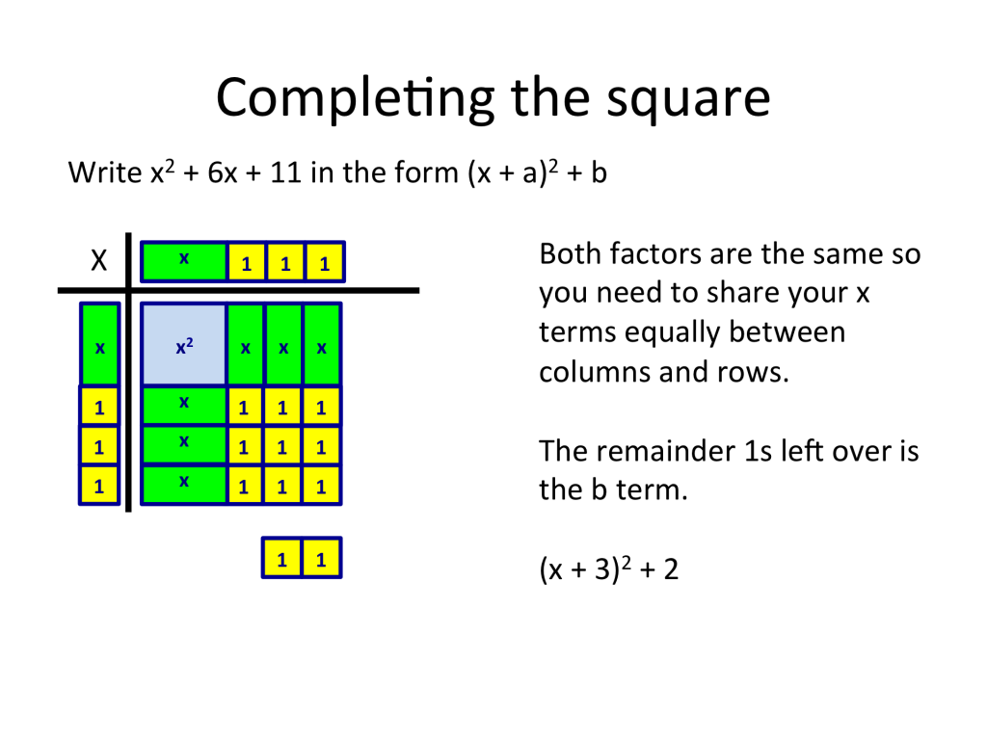

Use the drawings to write each equation in standard form and in vertex form.
Standard Form | Drawing | Vertex Form
$x^{2}+4x+7$ | 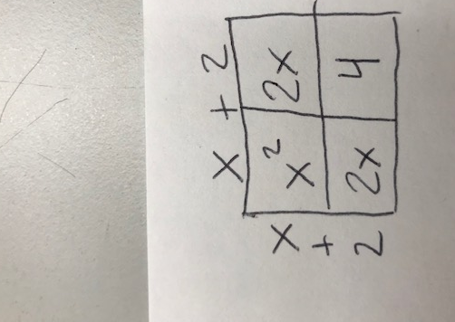
 |  | $(x+7)^{2}-9$
 | 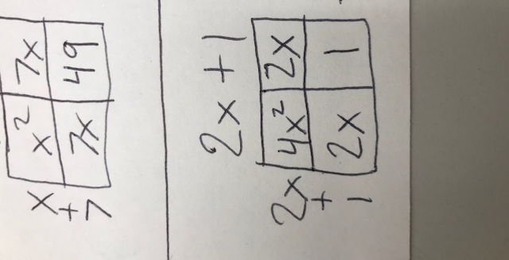
We did these problems before in this unit. Try to solve them again. Notice how the equations are all in vertex form.
Equations | Graphs:
${2(x-3)}^{2}-4=4$ | 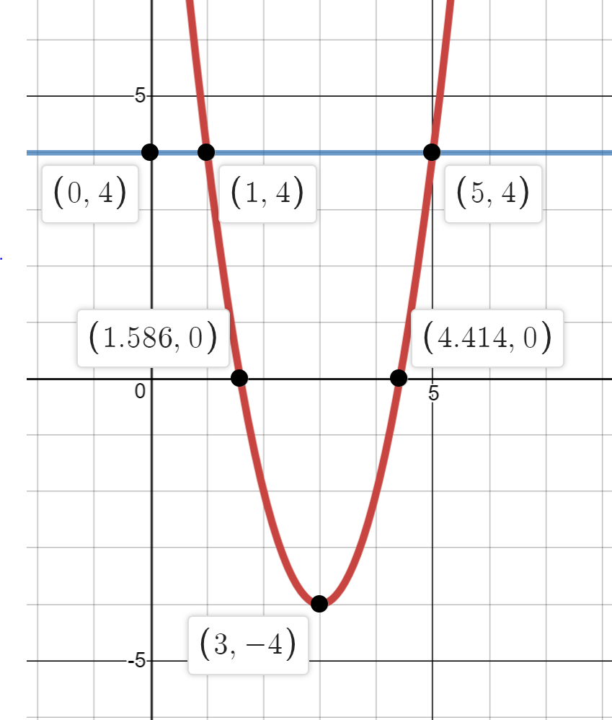
$-3({x+3)}^{2}+6=3$ | 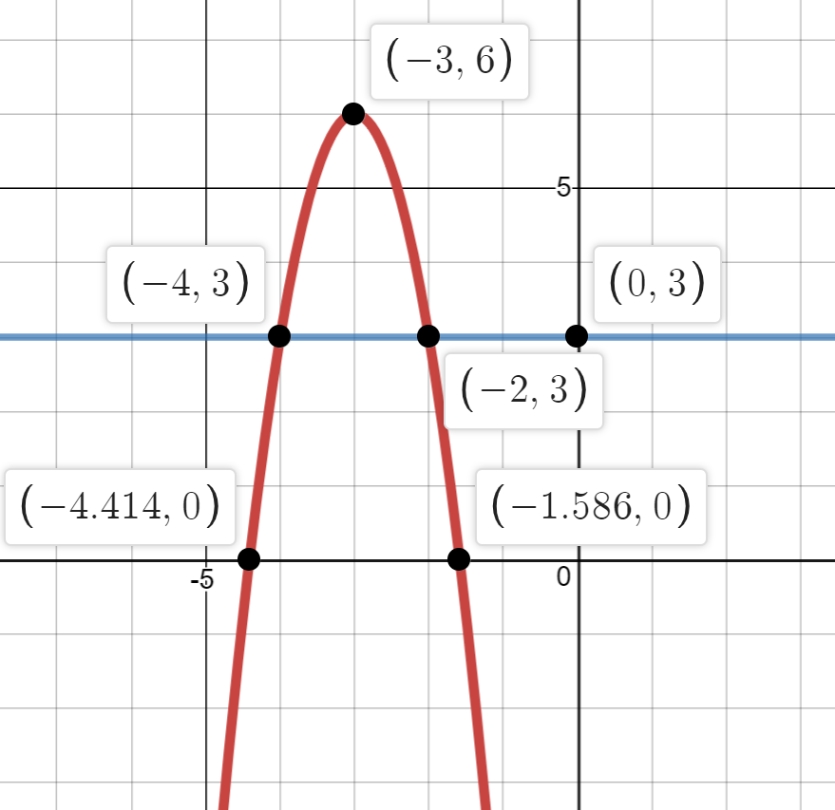
$-{16(x-3)}^{2}+144=80$ | 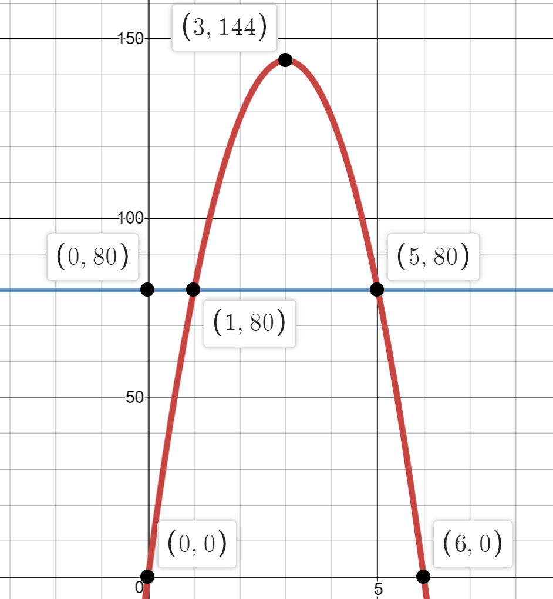
Now you will get equations in STANDARD form. First, complete the square to rewrite the equations in VERTEX form. Then, solve for x. Check with the graphs.
Equations | Graphs:
$x^{2}+4x+5=5$ | 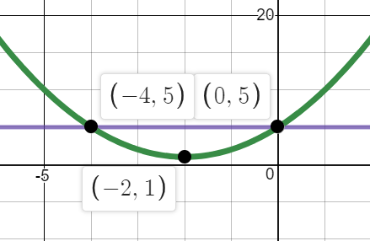
$x^{2}+8x+5=5$ | 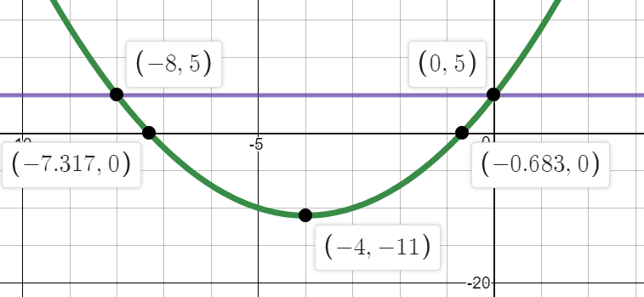
$x^{2}-2x+5=5$ | 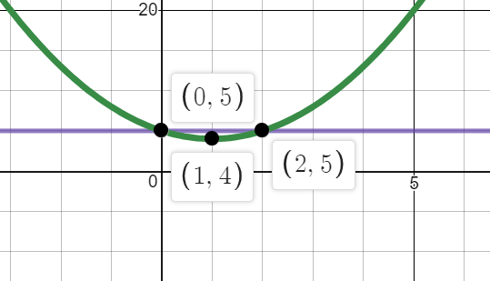

Reflect:
- What part of the graph does STANDARD form tell you?

- What part of the graph does VERTEX form tell you? (Don’t overthink it)

- What part(s) of the graph are the SOLUTIONS to the equation?

Mixed Practice: Solve each equation below by completing the square. Check your answers by graphing.
- $x^{2}+8x+14=14$

- $x^{2}-8x+14=14$

- $x^{2}+8x+14=-2$

- $x^{2}+8x+14=-14$

- Can you explain why you got different numbers of solutions in those problems? Use your graphs to help explain.

