Algebra 1/2 Day 28: The Big Race! (Introduction) #28

What is function notation?
Function notation is a way to talk about multiple characters in the same problem. In this activity, the three Algebra teachers, Ellen Maiden, Chelsea Muhs, and Ian Maurer will run preliminary heats (qualifying races) to determine who advances to “The Big Race.”

Because there are multiple characters running the heat, we need a way to communicate which x and y-value we are talking about. Enter function notation. We will use E(x) to stand for Ellen Maiden’s distance, C(x) to stand for Chelsea Muhs’ distance, and I(x) for Ian Maurer’s distance. E, C, and I stand for the names of the characters, E(x), C(x), and I(x), stand for their distance, and x stands for the time they spend running (in seconds).

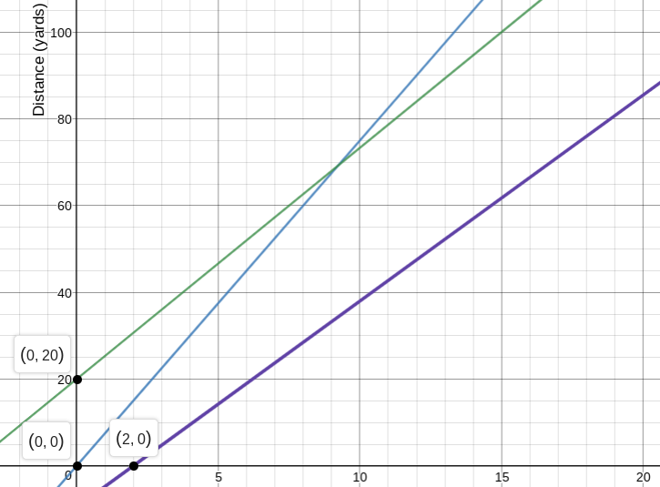
Heat 1: In the first heat, Ms. Maiden, Ms. Muhs, and Mr. Maurer run a 100-yard race. The graph below shows their distance over time. Ms. Maiden requests a 20-yard head start. Ms. Muhs takes off right at the starting gun. Mr. Maurer is distracted by a raccoon in the distance, so he trembles in fear for 2 seconds before he starts running.

1a. Label the three lines with E(x), C(x), and I(x) based on the information in the paragraph above.

How did you choose which line to label with each character?

1b. Who wins the heat? Who gets last place? How do you know?

1c. Who is running the fastest? Who is running the slowest? How do you know?

1d. The slopes of the three lines are 16/3, 15/2, and 19/4. Match each slope to the character it represents.

1e. The equations of the lines are $y=\frac{15}{2}x$, $y=\frac{16}{3}x+20$, and $y=\frac{19}{4}(x-2)$ . Rewrite each equation using function notation to match it with the character it represents.

Heat 2: Mr. Maurer complains about the result of the first heat, claiming that the raccoon was an unfair distraction. Ms. Maiden also complains that Ms. Muhs is too fast and should have to run a little bit farther than the other two teachers. They decide to run another 100-yard race.

Ms. Muhs starts 10 yards BEHIND the starting line. Ms. Maiden and Ms. Muhs start running exactly at the starting gun. Mr. Maurer is still complaining about the raccoon distraction and takes 5 seconds after the starting gun to start running.

2a. Fill in each table (assume each teacher runs at a constant rate). Label each table with the character it represents (function notation).
x | 0 | 5 | 10 | 15
___(x) | -10 | 15 |  | 65

x | 0 | 5 | 10 | 15
___(x) | 0 |  | 46 | 69

x | 0 | 5 | 10 | 15
___(x) | ------- | 0 | 27 | 54

2b. Who wins the race? Who gets last place? How do you know?

2c. The equations for the three runners are $y=\frac{25}{5}x-10$, $y=\frac{23}{5}x$, and $y=\frac{27}{5}(x-5)$. Rewrite each equation using function notation.

2d. Use the distributive property on the equation $y=\frac{27}{5}(x-5)$.What does this new version of the equation tell you about the runner?

2e. The equation $y=\frac{25}{5}x-10$can be rewritten as the equation $y=5(x-2)$. This is like the distributive property in problem 2d, just backwards. Where did the 5 and the 2 come from? What does the new version of the equation tell you about the runner?

Heat 3: In the third and final (or is it?????) preliminary heat, Mr. Maurer vows to do better. Ms. Muhs throws a tantrum because Ms. Maiden barely beat her in heat 2. Ms. Maiden graciously offers to reduce her head start in the last heat. Ms. Muhs and Mr. Maurer will start ON the starting line and Maiden will start AHEAD of the starting line.

Mr. Maurer shows Ms. Muhs an instagram account dedicated to cats (catstagram). She is distracted by the catstagram for 3 seconds after the starting gun. Ms. Maiden reduces her head start to 5 yards. Mr. Maurer takes off running right at the starting gun. Muhs runs at 6.25 yards per second. Maiden runs 5.75 yards per second. Maurer runs 6 yards per second.

3a. The equations for the three runners are $y=5.75x+5$, $y=6x$, $y=6.25(x-3)$. Rewrite the equations using function notation.

3b. How do you represent a DISTANCE head start in an equation? How do you represent a TIME head start in an equation? Can you convert a TIME head start into DISTANCE?

3c. Use the distributive property on the equation $y=6.25(x-3)$. What does the new version of the equation tell you about the runner? Use the words TIME and DISTANCE in your answer.

3d. Use the equations to determine who wins the race. Who gets last place? How do you know?

3e. How long will it take for Ms. Muhs to catch up with Mr. Maurer after she stops looking at the catstagram? How far will they have run by then? What about Muhs catching Maiden?

Heat 4: Jason Ward, the 4th algebra teacher, is walking up Powell Boulevard when he spies the other three teachers racing each other. He says, “What the heck! Did they forget about me? I’ll show them…” He challenges the algebra team to a final heat. Use the information below to match up each teacher with each equation, graph, and table.

- J(x). Jason Ward decides he deserves a 15-yard head start. He can run 17 yards every 3 seconds.
- E(x). Ellen Maiden decides she deserves a 5-yard head start. She can run 20 yards every 3 seconds.
- C(x). Chelsea Muhs decides to give Ellen and Jason a 2-second head start. She can run 25 yards every 4 seconds.
- I(x). Ian Maurer decides to give Ellen and Jason a 3-second head start. He can run 13 yards every 2 seconds.

4a. Here are the 4 equations for the algebra teachers. Rewrite each equation in function notation so it is clear which equation works for which teacher.

$y=\frac{17}{2}(x-3)$ $y=\frac{17}{3}x+15$ $y=\frac{31}{4}(x-2)$ $y=\frac{20}{3}x+5$

4b. Here are the 4 graphs for the algebra teachers. Label each graph with the appropriate function.
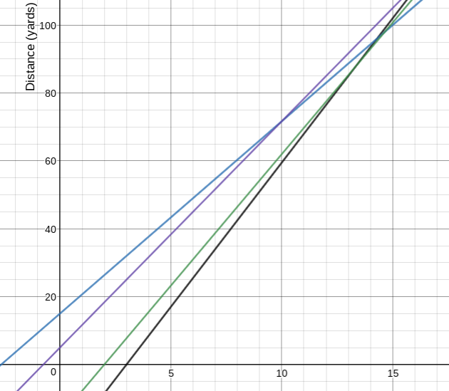

4c. Two of those graphs cross at the point (10, 71.667). Write a sentence that explains what that point means.

BONUS: Which two runners meet at the point (10, 71.667)?

4d. Who wins the race? How do you know?

