Algebra 2, Unit 9: Quadratics Day 29: Extra Practice - Challenging #29

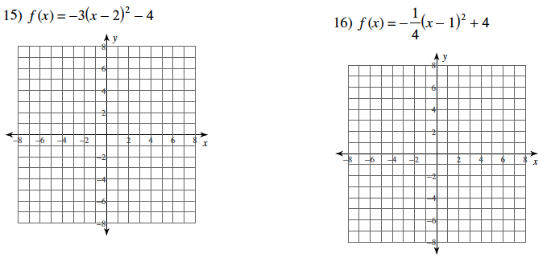
Identify the Vertex and Axis of Symmetry for each equation. Then, make a table and graph the equation.

21) 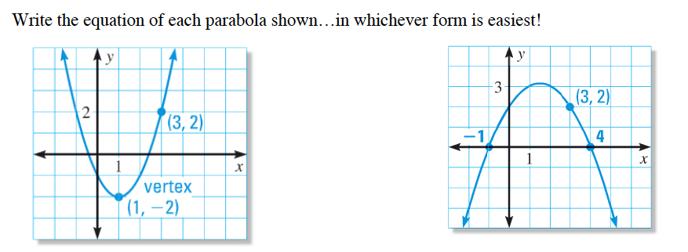
Hint: Write a “general equation” and then solve for the a-value.

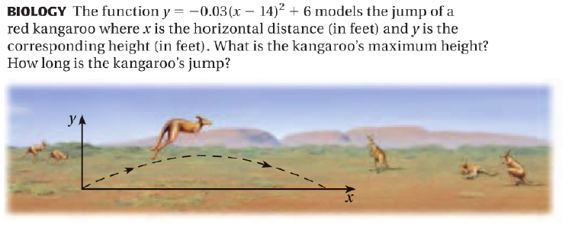
22)

