Algebra 3 Name:____________

2-Variable Inequalities

What is a Solution?
- Find a solution to the equation $x+5=12$. Are there any other solutions? Draw a number line and shade in the solution(s).

- Find the solutions(s) to the equation $(x-4)^{2}=25$. Draw a number line to represent all the solutions.

- Inequalities are similar to equations, but they are a little bit different. How are the solutions to $x+5>12$related to the solutions to $x+5=12$? Draw two number lines below, and clearly indicate the solutions to the inequality on one number line, and the solutions to the equation on the other number line.

- Now compare the equation $(x-4)^{2}=25$ to the inequality $(x-4)^{2}<25$. How are the solutions similar? How are they different? Represent them with two number lines.

- Remember that a solution is: Any number(s) you can plug in to make a true statement. We are now going to look at two variable equations. For two variable equations, the solution is an (x,y) point, because every variable needs a number to plug in. For the equation $y=x+1$, the point (3,4) is a solution because $3+1=4$, but the point (4,3) is NOT a solution because $4+1≠3$Write down two more solutions to $y=x+1$.

- When you have two variables, you can’t just draw one number line. So you draw a number line for the x values, and another number line for the y values (in other words, you make an xy graph). For the equation $y=12-3x$, the points (0,12), (1,9), (2,6), and (3,3) are all solutions. Draw your double number line graph below and indicate the solutions to the equation. What shape are they making? Write a note in your notebook about solutions to two-variable equations.

- Now consider the equation $y=(x-{3)}^{2}+4$. The point (3,4) IS a solution, whereas the point (4,3) is NOT. Write down at least 3 more solutions to the equation, and graph them.

- In problems 6 and 7, you should have discovered that a graph is nothing more than a picture of all the solutions to an equation. If you didn’t do it already, write notes about how you can graph solutions to an equation in your notebook. Then graph the solutions to the equation $y=2\left|x+3\right|-1$.

- Ok, now the new stuff. You can have two variable inequalities, just like you have two variable equations. The idea is the same: shade in ALL solutions to the inequality. I’ve got colored pencils if that helps. For example, for the inequality $y>x+2$, the points (0,3) (0,4) (0,5) and (0,100) are all solutions, because $x+2$is smaller than $y$. The points (10,10), (10,11) and (10,12) are NOT solutions, because $x+2$is greater than or equal to $y$. Write down 3 more points that are solutions and 3 more points that are NOT. Try to shade in all of the solutions on your graph.

- Recall that the solutions to a one variable EQUATION were the boundary point(s) on the number line. The solutions to a two variable EQUATION will be the boundary points on the xy - graph. You will then have to shade either ABOVE or BELOW the graph to catch all of the solutions. For the inequality $y>x^{2}+1$, I would first graph the parabola $y=x^{2}+1$, and then I would shade the region ABOVE the graph (because y>). Do that in your notebook (use calculator if you need help graphing).

- Last new thing. Remember that we used closed circles for $≤ or ≥$but we used open circles for $< or >$. The idea is similar for two variables. Use a solid graph for $≤ or ≥$ and use a dashed graph for $< or >$. Here’s a few examples.
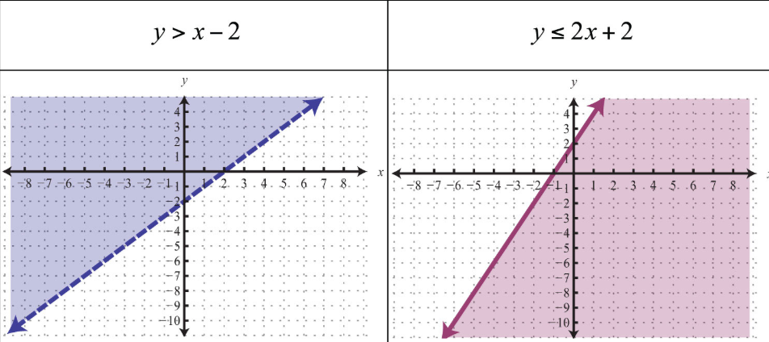
- In your math notebook, practice graphing each of the following:
  - $y>3x-5$ b. $y≤(x-4)^{2}-2$ c. $y<5-3\left|x+4\right|$

