Algebra 2, Unit 5: Quadratics #32
Day 32: Factoring Trinomials

We have learned about changing from factored to standard form by multiplying two binomials. Today, we will learn about going backwards (changing from standard form to factored form) by FACTORING.

First, let’s notice some patterns with multiplying…
1. Multiply these binomials out using any methods.
a. (x + 2)(x + 3) b. (x + 7)(x - 1)

2. Standard form is y = ax² + bx + c. What do you notice about the numbers in the original problems in factored form in #1, compared to the numbers in the standard form after you multiplied them out?

Summarize:
(x + p)(x + q) = x² + bx + c, where p + q = ______ and p $⋅$ q = _____

We will use our understanding of these patterns you noticed above to change from standard to factored form now. We will use a method similar to the “area model” we used previously, but in reverse.

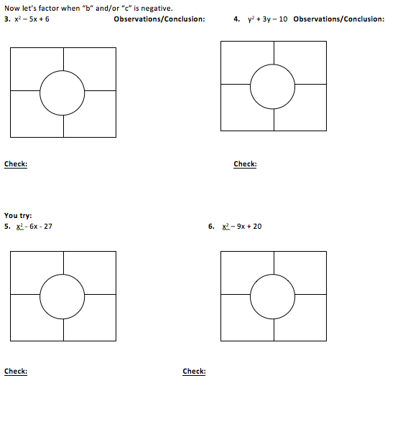

Practice: Factoring Trinomials

Factor the trinomials. Use the box method.
1. x² + 6x + 5 | 2. a² + 10a + 21
3. w² + 8w + 15 | 4. p² – 3p – 10
5. c² + 10c – 11 | 6. y² + 5y – 14

