Alg 1/2, Unit 5: Two-Variable Statistics #35
Day 35: Scatter Plots

Read this diagram explaining important qualities of scatterplots:

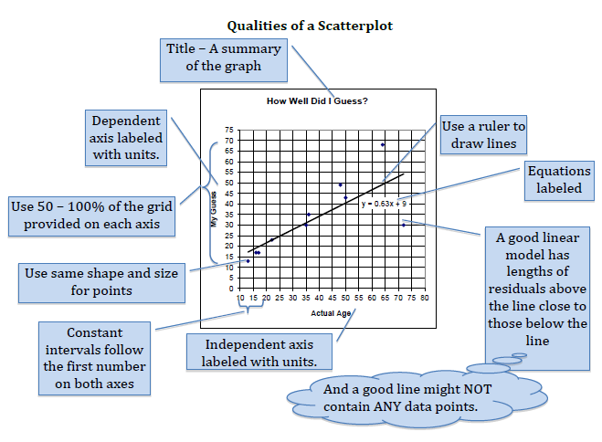

FInd the Errors

Each scatterplot below has graphed the data in the table as a scatter plot. Use your understanding of what a GOOD scatter plot is to describe the mistakes in each problem. Write your explanations on your OWN piece of paper.

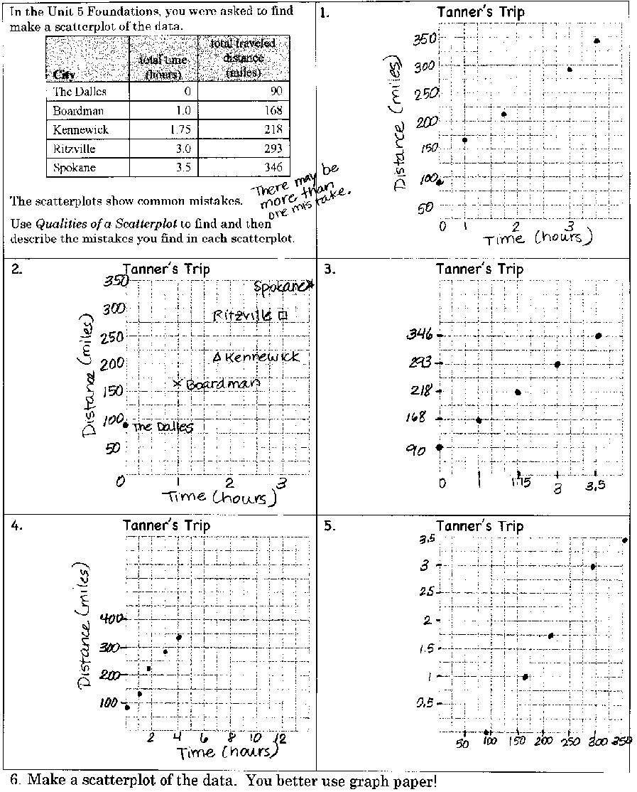

How accurate are you at guessing people’s ages??

All of the people listed below are celebrities. Write in your GUESS of their age, even if you don’t know who it is. Then when you’re done, I’ll show you their ACTUAL age. Record their actual age below too.

Person | Guess | Actual Age
Barack Obama
Katy Perry
Stephani Germanotta
Lebron James
Ashley Nicolette Frangipane
Ms. Maiden
Jay-Z
Sarah Hyland
Robert De Niro
Rico Rodriguez

Celebrity Ages

Guessed Age

Actual Ages
Line of Best Fit

In many of your classes, you may be asked to predict a value based off of given data. You can do this by finding the line that best fits the data.

Step 1: Create a scatterplot of the data below showing how many hours students watched television the night before their Physics test.

Use the data to predict a reasonable test score for someone who
watched 4 hours of TV the night before the test. Explain.

Step 2: Does the data show a positive OR negative correlation? Y or N
If yes, then a line that best fits the data can be drawn!

Step 3: Draw a line that appears to fit the data closely. There
should be approximately as many points above the line as below it.

Commons Misconceptions:

1)

Students in Mrs. Stark’s class did a “Breaking Bridges” experiment. In this experiment they simulated making bridges out of paper layers and put a cup of pennies on the bridge. They recorded the number of layers and the number of pennies that made the bridge break.

- Make a scatterplot of the data →
- Describe the correlation of the data in the
scatterplot.

- Draw a line of best fit that can be used to estimate data.
- Predict how many pennies will make the bridge break when there are 10 layer.

