Algebra 2, Unit 6: Systems Day 7b: Practice #7b

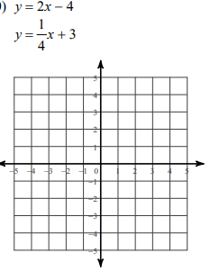
1) Solve by graphing. 2) Solve by substitution. 3) Solve by elimination.
$2x - 2y = 4$ $-7x + y = -19$
$y = -3x + 14$ $-2x + 3y = -19$

Algebra 2, Unit 6: Systems Day 7b: Practice #7b

1) Solve by graphing. 2) Solve by substitution. 3) Solve by elimination.
$2x - 2y = 4$ $-7x + y = -19$
$y = -3x + 14$ $-2x + 3y = -19$

