Algebra 3-4 Name: ________________________ Per:_____
1st Semester Review Unit 1 HW Date: ___________________________

- Solve algebraically. Check your solutions.
- $-3\left|x+1\right|+4≥-8$

- $\sqrt{x+3}+4>6$

- $3\sqrt{4x+3}=33$

- $7x^{\frac{1}{6}}=56$

- $2{\left(x+3\right)}^{2}=50$

- $\left|2x-4\right|+1=21$

- Solve the system of equations:

$\left\{\begin{aligned}y=-3x+4 \\ y=3x-2\end{aligned}\right.$ $\left\{\begin{aligned}x-y=3 \\ 7x-y=-3\end{aligned}\right.$

$\left\{\begin{aligned}-16y=22+6x \\ -11y-4x=15\end{aligned}\right.$ $\left\{\begin{aligned}y=x^{2}-7x+14 \\ y=x-1 \end{aligned}\right.$

- The school that Lisa goes to is selling tickets to the annual talent show. On the first day of ticket sales the school sold 4 senior citizen tickets and 5 student tickets for a total of $102. The school took in $126 on the second day by selling 7 senior citizen tickets and 5 student tickets. What is the price each of one senior citizen ticket and one student ticket?

- Seven smoothies and twelve cookies cost a total of $\$54.65.$ Twelve smoothies cost $\$13.35$ less than 27 cookies. Find the cost of a smoothie and the cost of a cookie.

Algebra 3-4 Name: ________________________ Per:_____
1st Semester Review Unit 2 HW Date: ________________________

- Define the following:
- Domain:
- Range:
- Function:

- For each graph give the domain, range, and decide if it is a function.
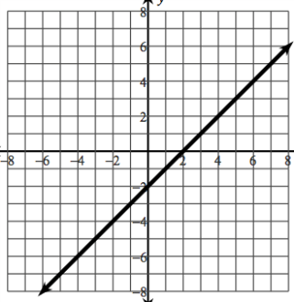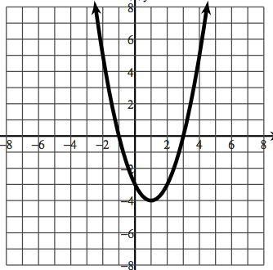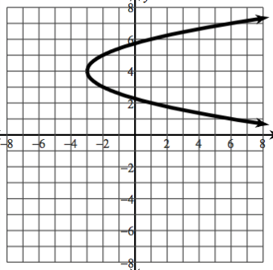

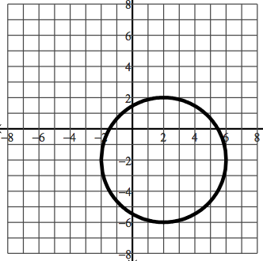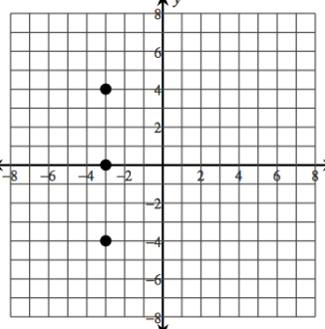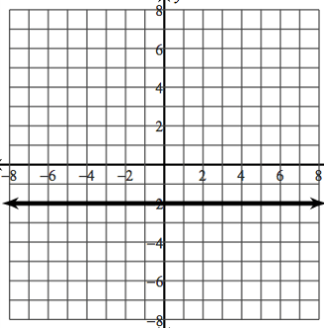

- Evaluate the following expressions given the functions below:

$$g\left(x\right)=-3x+1$$

$$f\left(x\right)=x^{2}+7 \\ h\left(x\right)=\frac{12}{x}$$
$$j\left(x\right)=2x+9$$

$$g\left(10\right)=$$
$$f\left(3\right)=$$
Find $g\left(x\right)=16$
$$h\left(-2\right)=$$
Find $f\left(x\right)=23$
$$j\left(7\right)=$$
Find $h\left(x\right)=-2$
Find $f\left(h\left(x\right)\right)$

- Given the graph of the function, find: 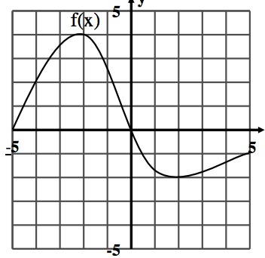

$$f\left(-4\right)=$$
$$f\left(0\right)= \\ f\left(3\right)=$$
x when $f\left(x\right)=2$
x when $f\left(x\right)=0$

- Find the inverses of each.

- f(x) = $\sqrt{3x-7}$+ 2

- verify the following are inverses. Show all work.

- 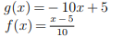
- 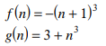

Algebra 3-4 Name: ________________________ Per:_____
1st Semester Review Unit 3 HW Date: ________________________

1. Write an exponential equation that goes through the points (4, 31.1) and (10, 92.88).

2. Write an exponential equation to model the population 'x' years after year zero.

x: # years after year zero | 0 | 1 | 2 | 3 | 4 | 5
y: population |  |  | 15,252 |  |  | 28,730

3. Solve. a) x⁵= 18 b) 3^{2x-3}=30

c) log₅8 = 3x + 4 d) 2(5)^{x-5} – 3 = 55

e) 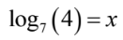 f) 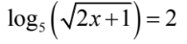

4. The average cost of a movie ticket is $9.50. The price increases 2.5% per year.
  - Write an exponential equation to model this situation. Define your variables.

  - What will be the cost of a movie ticket in 5 years?

  - Assuming the price continues to grow at this rate, how long will it take until the price of a ticket doubles? Show ALL work.

  - To stay in business movie theaters need the price of tickets to increase to $25 within the next 10 years. What percent growth would be required for movie theaters to meet this goal? Show ALL work.

5. Find the inverse of f(x) = log₂(x – 1) + 2 .
Check your inverse by finding some points on f(x) and f⁻¹(x).

Algebra 3-4 Name: ________________________ Per:_____
1st Semester Review Unit 4 HW Date: ______________________________

*** NO CALCULATOR *** NO CALCULATOR *** NO CALCULATOR ***
      - Describe what transformations a, h, and k perform. $y=a\left(x-h\right)+k$

      - Write the equation of an absolute value function with a vertical stretch of 2, is shifted 3 units right, and is 4 units down.

      - Write the equation of a square root function that is reflected over the x-axis, has a vertical compression of $\frac{1}{3}$ and is shifted 7 units up.

      - For the following equations rewrite in the requested form(s). Then sketch a graph of each.
- Write in standard form:
$$y=3{\left(x-4\right)}^{2}$$
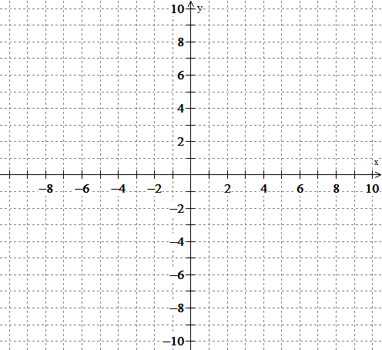
- Write in vertex form:
$$y=x^{2}-2x-8$$
- Write in vertex form: (hint: write in standard form first!)
$$y=\left(x+3\right)\left(x-1\right)$$

      - Graph each equation without a calculator.
a) $f\left(x\right)={\left(x+5\right)}^{3}+2$ b) $f\left(x\right)=-\frac{1}{2}\left|x-3\right|+2$ c) $f\left(x\right)=3\sqrt{x-2}-5$

      - Write the equation of each graph:
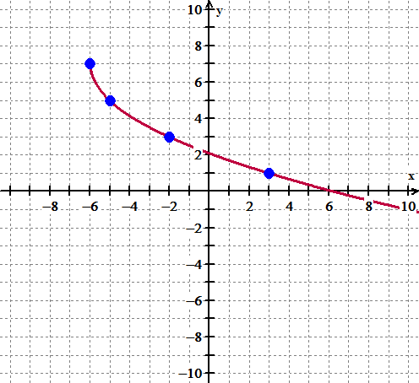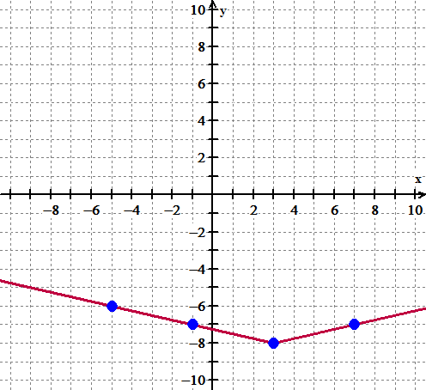
      - Find the exact equation of an absolute value function with a locator point at $\left(1, 3\right)$ and passes through the point $\left(7, 6\right)$.

      - Find the exact equation of a cubic function with a locator point at $\left(-2, -4\right)$ and passes through the point $\left(-3,-7\right)$.

9. Factor.

- $b^{2}-6b+8$
- $2n^{2}+6n-108$
- $6x^{2}+5x-6$
- $4x^{2}-4x+1$

