CCSS Advanced Algebra 3 AA4: Transformations Review Name_______________________
Part 1: Write the expression that fits each blank. Then name the transformation(s).

$f(x)=x^{2}$ $g(x)=|x|$ $h(x)=\sqrt{x}$ $j(x)=x^{3}$ $k(x)=\sqrt[3]{x}$

Expression | $f(x+2)=$__________ | $2g(x)=$_________ | $h(x)-4=$________ | $j(0.1x)=$________
Transformation
Expression: | $2k(x-1)=$__________ | $g(2x)+4=$_______ | $f(2(x-5))=$______ | $4h(x)+3=$_______
Transformation

Part 2: Write the equation for each function described below:

1. Parent Quadratic function ($y=x^{2})$is reflected over the x-axis, translated down 4 units and left 2 units.

2. Parent Cubic function ($y=x^{3}$) is stretched vertically by a factor of 3, translated right 5 units and up 1 unit.

3. Parent Square Root function ($y=\sqrt{x}$) is reflected over the y-axis, compressed vertically by a factor of $\frac{1}{2}$ and translated left 4 units.

4. Parent Cube Root function ($y=\sqrt[3]{x}$) is reflected over the y-axis, compressed horizontally by a factor of 8 and translated up 3.

5. Parent Absolute Value function ($y=|x|$) is stretched vertically by a factor of 2, translated right 3 units and reflected over the x-axis.

6. Parent Linear function ($y=x$) is reflected over the x-axis, stretched vertically by a factor of 4 and translated right 2 units.

Part 3: Find the exact equation of each function described below.

- Parent quadratic function with a vertex of (2,-3) that passes through the point (3,12)

- Parent cubic function with an inflection point of (-4, -3) that passes through the point (-5,2)

- Parent square root function with a vertex of (3,5) that passes through the point (7,-3)

- Parent cube root function with an inflection point of (-1,-1) that passes through the origin

- Parent absolute value function with a vertex of (7, -3) that passes through the origin

Part 4: Find the exact equation of each graph below:
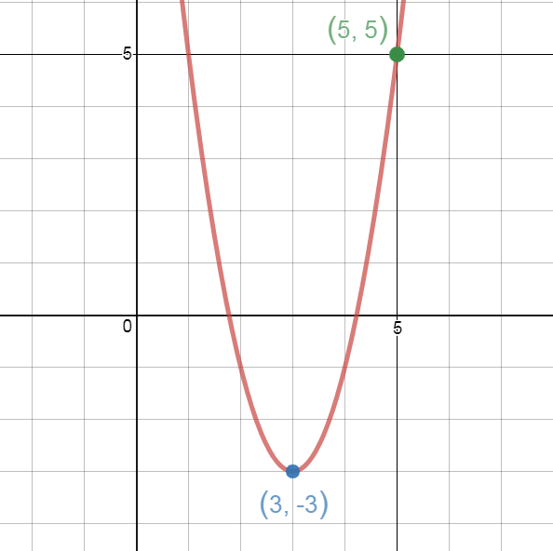 | 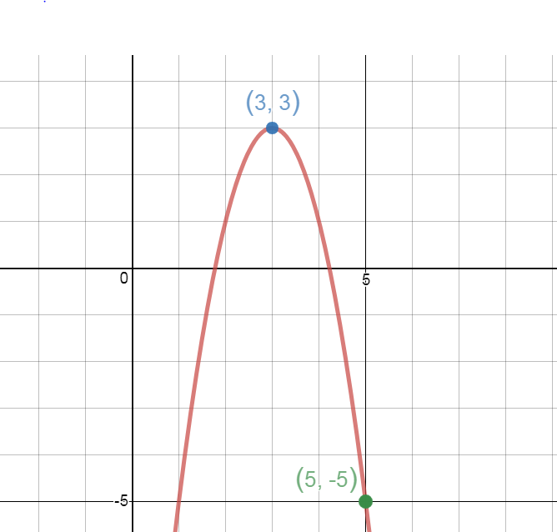 | 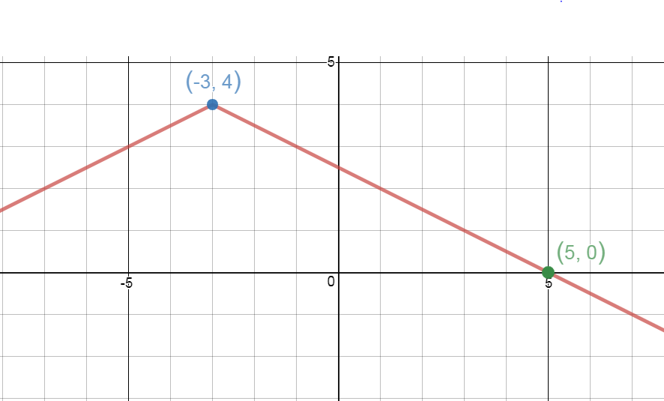
Equation: | Equation: | Equation:
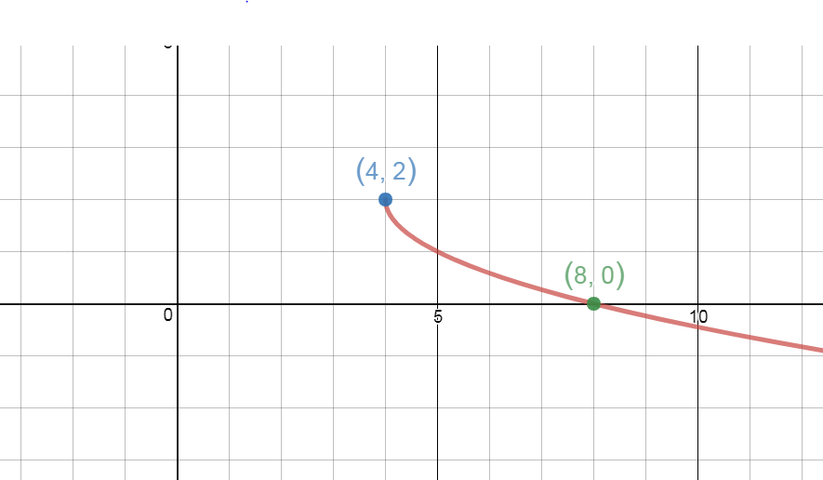 | 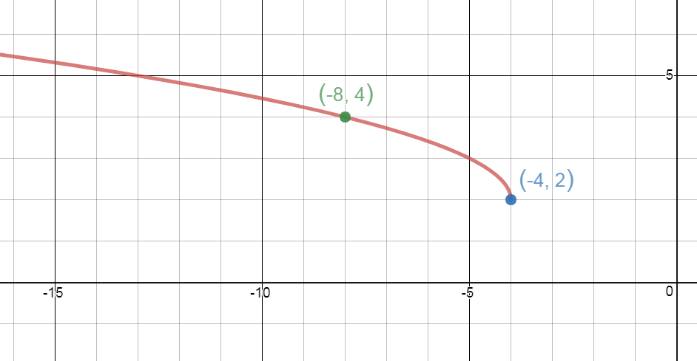 | 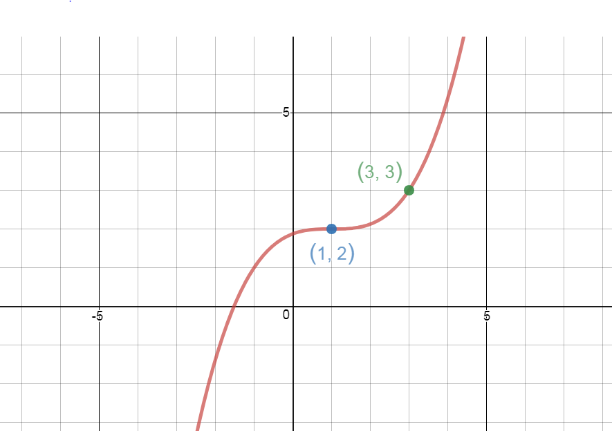
Equation: | Equation: | Equation:

