Algebra 3-4 Name: ________________________ Per:_____
Unit 2 Day 1 PreTest Date: _________________________

- Describe the transformations of $f\left(x\right)=x^{2}$ for the function below:
$g\left(x\right)=-{\left(x+3\right)}^{2}+2$

- What is the vertex of $g\left(x\right)=-{\left(x+3\right)}^{2}+2$?

- Write $y=x^{2}+4x+1$ in vertex form.

- Given the following parent functions, match the parent function with its graph.

Parent Functions:
- Cubic $f\left(x\right)=x^{3}$
- Square Root $f\left(x\right)=\sqrt{x}$
- Absolute Value $f\left(x\right)=\left|x\right|$
- Linear $f\left(x\right)=x$
- Quadratic $f\left(x\right)=x^{2}$

Graphs:
_____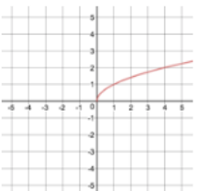

_____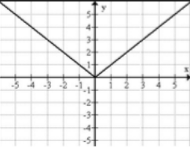

_____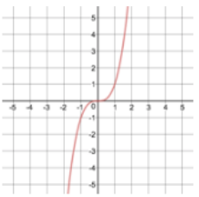

_____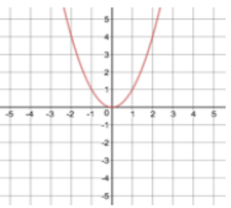

_____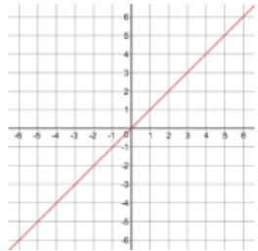

Graphing Linear Functions:
Graph the lines y= 3x+1, y=5x+1, and y= -2x+3 on the axes below.
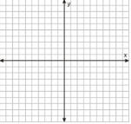
Describe how, when given an equation in “y=mx+b” form, you can draw an accurate. Be specific and detailed.

What is the difference between a positive and negative slope?

Graphing Quadratic Functions:
Graph the parabolas $y=x^{2}$, $y=x^{2}+3$, and $y={(x+3)}^{2}$ on the axes below.
Describe what “adding 3” can do to the graph of a parabola. Be specific and detailed. In particular, describe the difference between “adding 3 inside the parentheses” and “adding 3 to the end of the equation.”

