Algebra 3-4 Name: ________________________ Per:_____

Ch 8 Day 11 REVIEW Date:

$\sin\left(θ\right)=\frac{ }{ }$ $\cos\left(θ\right)=\frac{ }{ } \tan\left(θ\right)=\frac{ }{ }$

_____________________

1. **Find the missing side in each triangle. SHOW ALL WORK.**

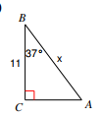 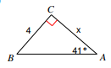

1. Locate each angle below on the Unit Circle, then write down the value of the trig function listed. DO NOT use a calculator.

|  |  |  |
| --- | --- | --- |
| **1)** sin 135o | **2)** cos 225o | **3)** tan 45o |
| **4)** sin | **5)** cos | **6)** tan |
| **7)** sin 510o | **8)** cos 600o | **9)** tan -30o |
| **10)** sin | **11)** cos | **12)** tan |
| **13)** sin -120o | **14)** cos 330o | **15)** tan -180o |
| **16)** sin | **17)** cos | **18)** tan |

1. Find the angle(s) described below on the Unit Circle, then write down the angle measure(s) in radians. DO NOT use a calculator.

|  |  |  |
| --- | --- | --- |
| **1)** | **2)** | **3)** |
| **4)** | **5)** | **6)** |
| **7)** | **8)** | **9)** undefined |
| **10)** | **11)** | **12)** |
| **13)** | **14)** | **15)** |
| **16)** | **17)** | **18)** |

|  |  |  |
| --- | --- | --- |
| **PARAMETER** | **y = a ● sinb(x-h) + k** | **y = a ● cosb(x-h) + k** |
| **PARENT GRAPH** | y = sin(x) | y = cos(x) |
| **AMPLITUDE**  **(“a”)** | y = 2sin(x) | y = 2cos(x) |
| **VERTICAL POSITION**  **(“k”)** | y = sin(x) + 1 | y = cos(x) + 1 |
| **HORIZONTAL POSITION**  **(“h”)** | y = sin(x - π/2) | y = cos(x - π/2) |
| **PERIOD CHANGE**  **(“b”)** | y = sin(2x) | y = cos(2x) |

8. Graph each equation.

**a)**  **b)** 

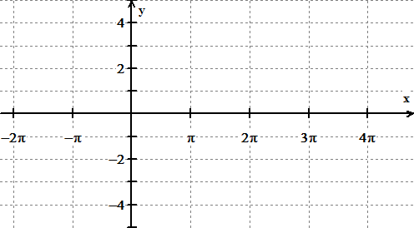 

**c)**  **d)**

 

9. Write an equation for each of these graphs.

**a)** **b)**

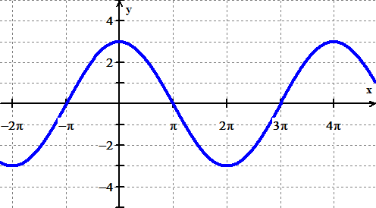 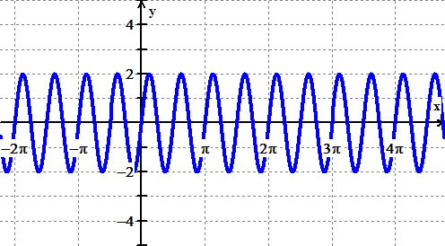

**c)** **d)**

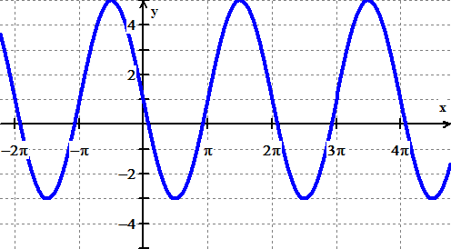 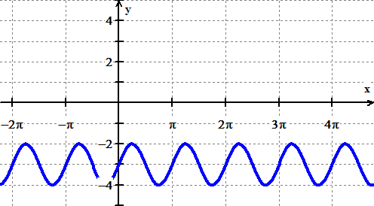

1. A unit circle has angle  in standard position. Point *P* is on the circle and the coordinates of *P* are shown.
   1. What is cos? Explain what it means in terms of the sun.

ß

*P*

*x*

*y*

* 1. What is sin? Explain what it means in terms of the sun.
  2. What is the measure of angle ? Give your answer in radians *and* degrees.

Solve for $θ$ using simplification and your unit circle.

$2\sin{θ}=1$

$cosθ-1=-0.50$

$4\tan{θ=4}$

1. If angle $θ$ is in the third quadrant and $\tan{θ}=\frac{1}{2}$, what is sine of that angle?

