Algebra 2, Unit 6: Systems of Equations #4
Day 4: Substitution

The last few classes we learned how the solution to a system of equations can be solved by graphing (the solution is the point of intersection) and also in a table (when the x- and y-values are the same). Today we will learn a NEW STRATEGY.

1) THE HILLS ARE ALIVE!
The Alpine Music Club is going on its annual music trip. The members of the club are yodelers, and they also like to play the xylophone. This year they are taking their xylophones on a gondola to give a performance at the top of Mount Monch.
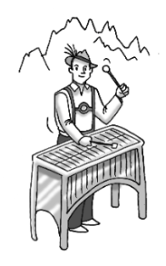
The gondola conductor charges $2 for each yodeler and $1 for each xylophone. It costs $40 for the entire club, including the xylophones, to ride the gondola. Two yodelers can share a xylophone, so the number of yodelers on the gondola is twice the number of xylophones.

How many yodelers and how many xylophones are the gondola?

Your Task:
- Represent this problem with a system of equations. Solve the system and explain how its solution relates to the yodelers on the music trip.
- Represent this problem with a graph. Identify how the solution to this problem appears on the graph.

Define variables and write a system of equations | Solve the system algebraically
Algebra 2, Unit 6 Day 4b: Practice Substitution Method #4b
4) Solve using the substitution method:
a) $2x+2y=18$  $x=3-y$ | b) $c=-b-11$  $3c+6=6b$

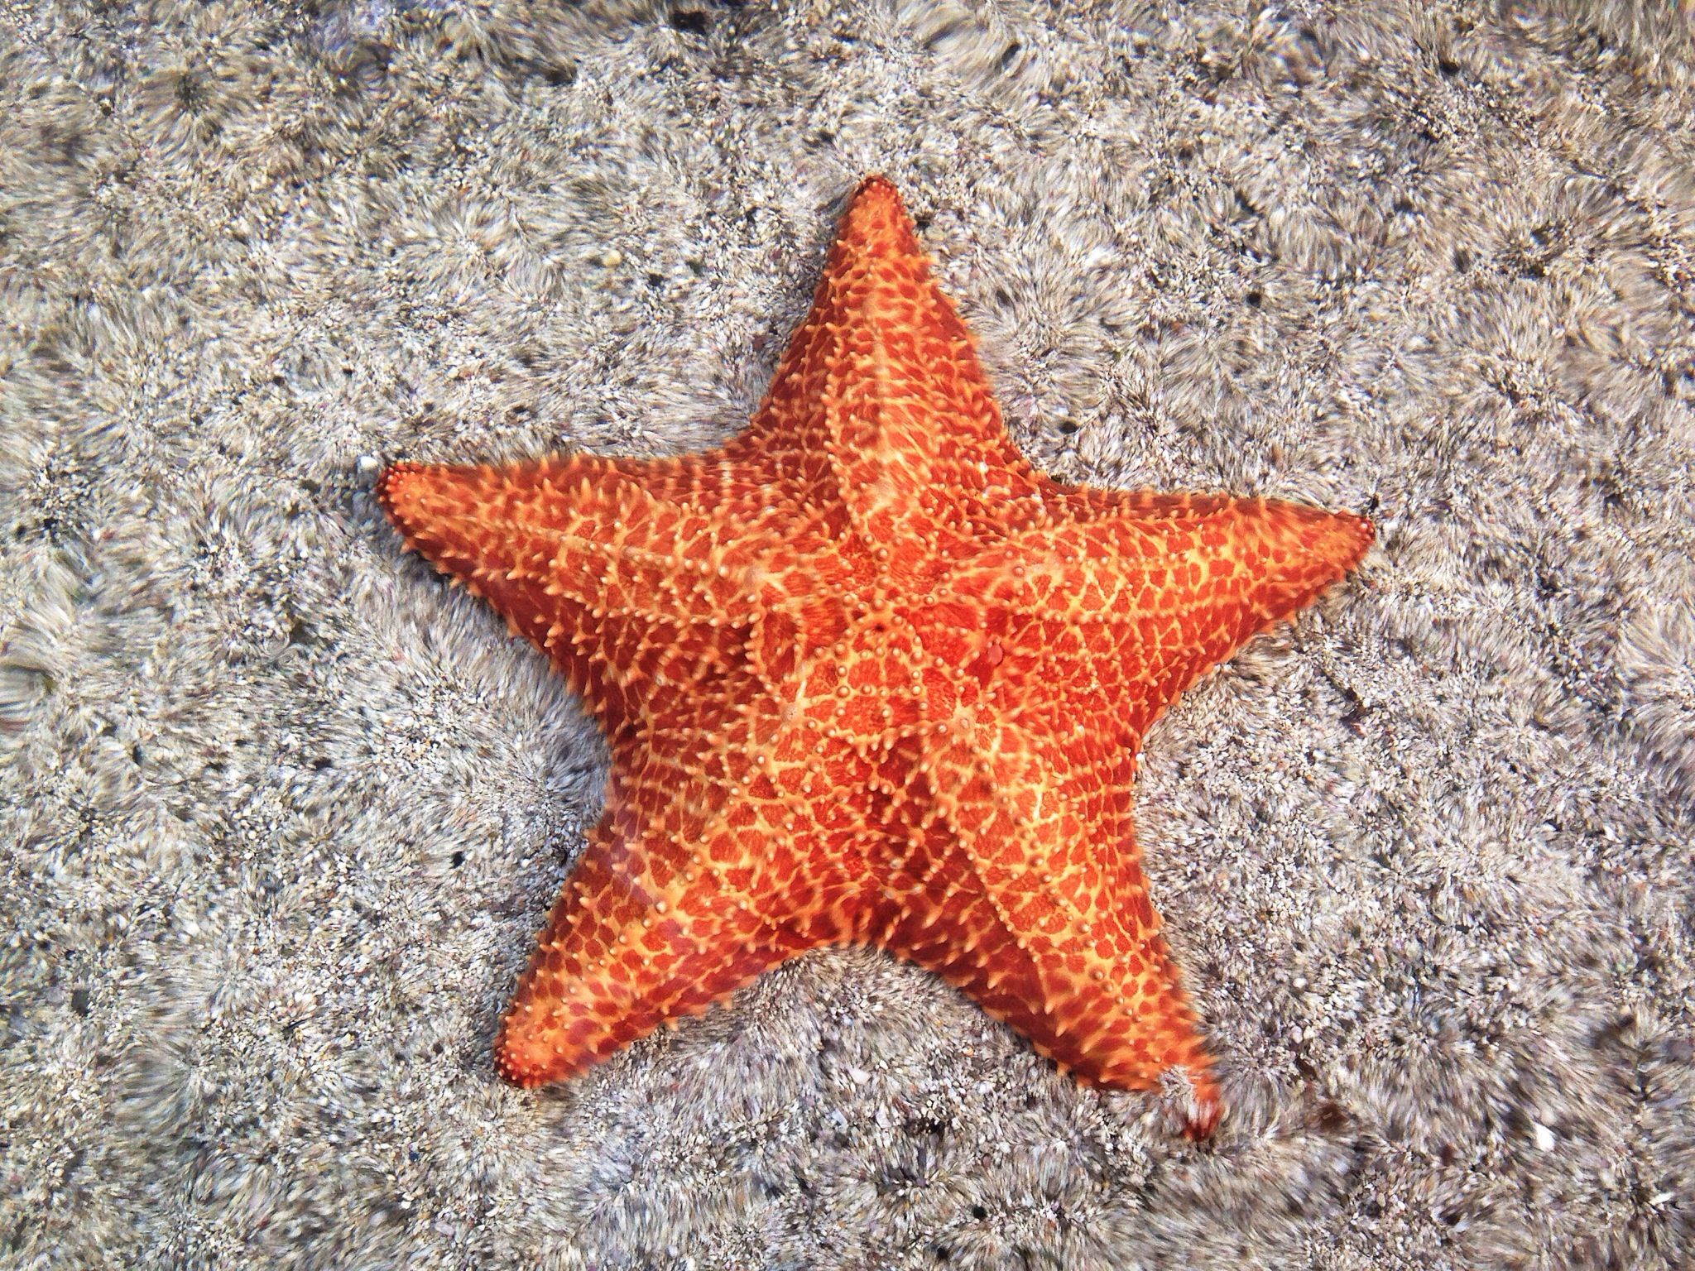
5) You’re at the Newport Aquarium and in one tank there are only octopuses and starfish. You count a total of 190 legs in one tank. The amount of octopuses is equal to the number of starfish plus one. Write a system of equations to represent the problem, then solve with substitution.

- Why is it impossible to have only 10 legs in the tank?

- Come up with totals of legs that is IMPOSSIBLE in the tank. Try to find as many as you can.

