CCSS Algebra 4 AA6: Polynomials Review
C Level Questions
1. Simplify each polynomial expression. Write the solution in Standard Form:
a. $(4x^{3}-10x^{2}+2x-7)+(3-2x-5x^{2}-7x^{3})$ b. $(4x^{3}-10x^{2}+2x-7)-(3-2x-5x^{2}-7x^{3})$

c. $(2x-7)(3x^{2}-5x+1)$ d. $\frac{6x^{3}-29x^{2}+32x-14}{2x-7}$

2. Simplify each rational expression fully.
a. $\frac{4x}{x+1}+\frac{4}{x+1}$ b. $\frac{x^{2}}{x-1}-\frac{1}{x-1}$ c. $\frac{2}{2x-2}⋅\frac{x-1}{x+3}$

3. Write a polynomial function in Factored Form for each description below:
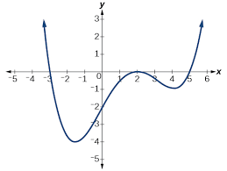
a. x-intercepts at (3,0), (4,0), (5,0) and a degree of 5. b.

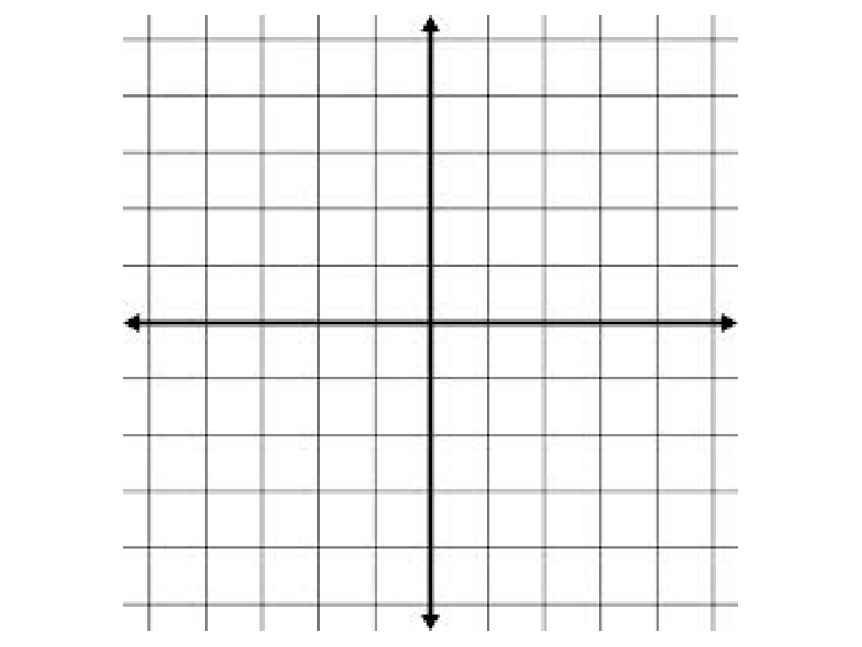
4. a. Factor $t(x)=(x^{2}+2x+1)(x^{2}-1)$.

b. Identify the x-intercepts and state the multiplicity of each root.

c. Use the x-intercepts and multiplicities to sketch the graph of $t(x)$.
d. Describe what happens to $t(x)$ when $x→-∞$
and when $x→∞$.

A/B Level Questions
5. The polynomial $m(x)=a(x-b)^{2}(x-c)$ has a leading coefficient of -10, a constant of 120 and the root with multiplicity one is 3. Find a, b, and c.

6. Consider the function $p(x)= -2x^{6}$. Explain why $p(x)<0$ when $x→∞$ and $p(x)<0$ when $x→ -∞$.

7. a. Show that $(x+1)^{2}=x^{2}+2x+1$

b. Show that $(2x+2)^{2}=4x^{2}+8x+4$

c. Hence, what does $(3x+3)^{2}=$ ?

d. Hence, what does $\frac{a^{2}x^{2}+2a^{2}x+a^{2}}{ax+a}$= ?

8. Solve the equation $\frac{2}{x+1}-\frac{1}{x-1}=0$ for x. Check your solution(s).

