CCSS Algebra 4 AA8_3: Creating a Random Sample

SURVEYING AND SAMPLING
A STATISTICAL QUESTION is one that you can give evidence of using statistics like MEAN, MEDIAN and STANDARD DEVIATION or graphical representations like HISTOGRAMS and BOX PLOTS.

1. Decide if each of the following questions are STATISTICAL QUESTIONS: Explain why or why not?
A. Do Freshmen or Seniors tend to have better balance?

B. Who typically has a greater ratio of height to wingspan ratio, males or females?

C. Do southern hemisphere countries have more crocodiles that northern hemisphere countries?

D. Did Portland have more rain in January 2018 or February 2018?

E. Does Portland typically have more rain in January or in February?

2. Kylie decided to examine question 1A and to measure balance by finding out how long people can stand on one foot.
a. How would you rephrase the question from Question 1A to create a statistical question using this definition of balance? Explain your reasoning.

b. Work with your group to devise a plan to select a random sample of Freshmen and a random sample of Seniors to measure their balance using Kylie’s method. Then, write a paragraph describing how you will collect data to determine whether there is a difference in how long Freshmen and Seniors can stand on one foot. Your plan should answer the following questions:
- What is the population?

- How will samples be selected from the population?

- Why is it important that they be random samples?

c What sample statistics will you calculate, and how will you display and analyze the data?

d. What would you accept as evidence that there actually is a difference in how long Freshmen can stand on one foot compared to Seniors?

Practice
3. The suggestions below for how to choose a random sample of students at your school were made and vetoed. Explain why you think each was vetoed.
a. Use every fifth person you see in the hallway before class starts.

b. Use all of the students taking math the same time that your class meets.

c. Have students who come to school early do the activity before school starts.

d. Have everyone in the class find two friends to be in the sample.

4. A teacher decided to collect homework from a random sample of her students rather than grading every paper every day.
a. Describe how she might choose a random sample of five students from her class of 35 students.

b. Suppose every day for 75 days throughout an entire semester she chooses a random sample of five students. Do you think some students will never get selected? Why or why not?

5. Sofia decided to use a different plan for selecting a random sample of books from a population of 150 top-selling children’s books. She generated ten random numbers between 1 and 100,000 to stand for the possible number of pages in any of the books. Then, she found the books that had the number of pages specified in the sample. What would you say to Sofia about her plan?

BIAS:
BIAS notes: Read the following notes about bias in surveys
The design of a statistical study is BIASED if it systematically favors certain outcomes.

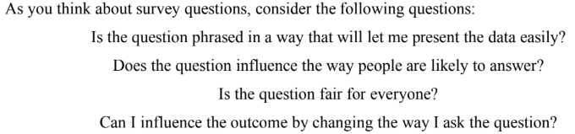

Things that can cause bias:
- Voluntary response sample: people chose themselves to be in the sample; when choice rather than randomization is used to obtain a sample; people with strong opinions are often over represented
  - Ex: write-in or call-in polls
- Undercoverage: groups in the population are left out of the process of choosing the sample; excluding or underrepresenting some part of the population
- Response: people lie when uncomfortable or desire to please the interviewer
- Nonresponse: when an individual chosen for the sample can’t be contacted or does not cooperate; when individuals selected for the sample fail to respond, cannot be contacted, or decline to participate
- Wording of questions: confusing or leading wording
- Question Order: The order of questions in a survey can bias the responses.

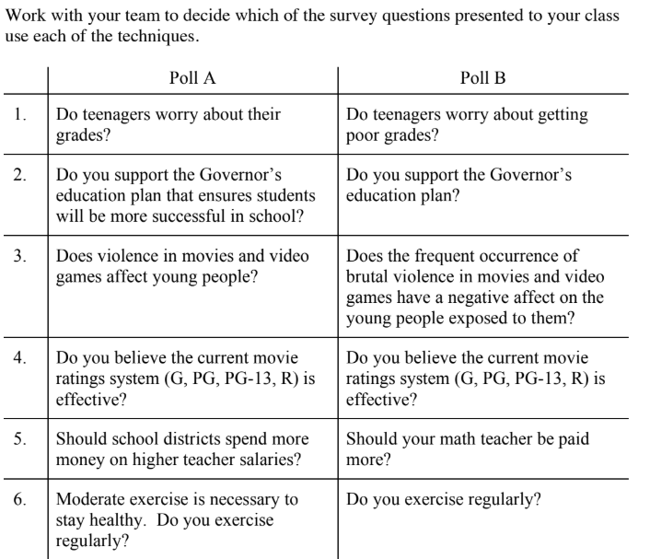

II. Writing Survey Questions:

One of the major challenges around using surveys to collect data is the formation of unbiased questions. Biased survey questions can increase the chance of someone answering the question in a particular way or make it more difficult for the responders to answer accurately.

Below are a variety of survey questions. With your team, discuss how the questions may be biased and how the bias could affect the data collected from the question. Be prepared to share your opinions with the class.

1. More people have attended the movie, Gone with the Wind, than any other motion picture produced this century. Have you seen this movie?
Yes No

2. In your opinion, how would you rate the speed and accuracy of your work?
Excellent Good Fair Poor

3. How do you feel about the following statement? We should not reduce military spending.
Strongly agree Agree Disagree Strongly disagree

4. People grow up in all different types of families. What type of family did you grow up in?
______Mom as single parent ______Dad as a single parent ______Both Mom and Dad

5. Where do you get most or all of your information about current events in the nation and the world?
__radio __Newspapers __Magazines __internet

6. Higher than single-family density is acceptable in order to make housing affordable.
Undecided Disagree Strongly Disagree Agree Strongly Agree

