CCSS Advanced Algebra 3 Card Sort: Transformations Check-In Name__________________

1. Identify each transformation (or transformations) below. Be specific.
Transformations:
HORIZONTAL TRANSLATION (Left or Right) | VERTICAL TRANSLATION  (Up or Down) | VERTICAL REFLECTION
HORIZONTAL REFLECTION | HORIZONTAL DILATION  (Stretch or Compress) | VERTICAL DILATION  (Stretch or Compress)
a. $f(x)+10$ b. $f(x-3)$ c. $f(x+8)$

d. $3f(x)$ e. $-f(x)$ f. $f(0.5x)$

g. $f(-x)$ h. $f(2(x-1))$ i. $f(x+3)+3$

2. Which image(s) below show a horizontal dilation and which show(s) a vertical dilation? How can you tell?
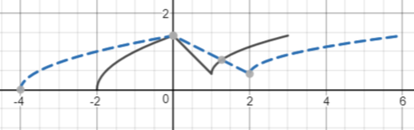
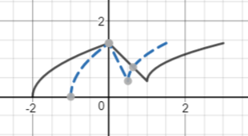
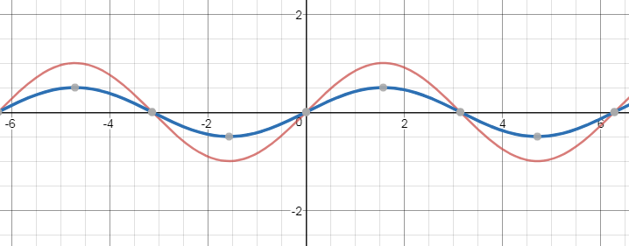
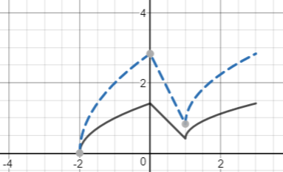

3. Let the Parent LINEAR Function be $g(x)=x$.
a. Explain GRAPHICALLY why a vertical translation up 1 unit results in the same function as a horizontal translation left 1 unit.

b. Will a VERTICAL REFLECTION of $g(x)=x$ look differently than a HORIZONTAL REFLECTION of $g(x)=x$ ? Explain how you know.

c. Is $h(x)=3x$ a VERTICAL or HORIZONTAL DILATION of $g(x)=x$? Explain how you know.

4. Consider the Quadratic Function $n(x)=x^{2}+10x+21$.
a. Factor to show that $n(x)=(x+\#)(x+\#)$.

b. The VERTEX is halfway between the x-intercepts. Find the x- and y-coordinates of the vertex.

c. What transformation(s) on $f(x)=x^{2}$ result in $n(x)$? Be specific.

d. Evaluate $n(0)$. What does $n(0)$ tell you about the GRAPH of $n(x)$?

e. Find the VERTEX of $n(x+1)-3$.

