CCSS Advanced Algebra 3 Match My Parabola Reflection

1. What is the difference between the graphs of $f(x)=x^{2}+1$ and $g(x)=x^{2}-1$?

2. What is the difference between the graphs of $f(x)=x^{2}+1$ and $h(x)= -x^{2}+1$?

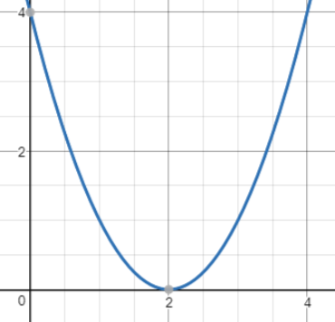
3. Linsey wants to create a design on desmos and started with the parabola shown. What equation did she use to create this parabola?

4. Without graphing, describe the differences in the parabolas that represent the function $p(x)=4x^{2}$ and $q(x)=0.25x^{2}$.

Vocabulary:
Parent Graph: the graphical representation of the most basic form of function family. The parent graph for Quadratic Functions is the graph of $y=x^{2}$.

Transformation: changes to the shape, orientation or location of the parent graph. There are three main types of transformations that we will study -- Translation, Dilation and Reflection (in Geometry, you also explored Rotation).
- Translation (Slide): moving all points on a graph horizontally or vertically a fixed amount.
  - Notation:
    - Vertical Translation $f(x)+k$
    - Horizontal Translation $f(x-k)$

- Dilation (Stretch or Compression): an increase or decrease in the height (vertical dilation) or width (horizontal dilation) of a graph by a factor. For example, $y=3x^{2}$ vertically stretches the parent function by a factor of 3.
  - Notation:
    - Vertical Dilation $k f(x)$
    - Horizontal Dilation $f(kx)$

- Reflection (Flip): mirroring a graph over a fixed line (typically the x-axis or y-axis).
  - Notation:
    - Vertical Reflection $-f(x)$
    - Horizontal Reflection $f(-x)$

7. For each function below, describe how the parent function $f(x)=x^{2}$was transformed. The first one is done as an example.
a. $y=x^{2}-3$ the parent function was translated 3 units down.

b. $y=x^{2}+10$

c. $y=(x-4)^{2}$

d. $y=0.5x^{2}$

e. $y=(2x)^{2}$

f. $y= -(x-1)^{2}$(describe both transformations)

g. $y=5(x+2)^{2}-5$ (describe all transformations)

