CCSS Advanced Algebra 3 More Quadratic Transformations:
1. Let $f(x)=(x+7)(x-5)$.
  - What are the x-intercepts of the function? y-intercept?
  - Consider the transformation $g(x)=f(x-2)$. What are the x-intercepts of $g(x)$?
  - Consider the transformation $h(x)=3f(x)-1$. What is the y-intercept of $h(x)$?

2. For the function $w(x)=x^{2}+6x+8,$
  - Find the x-intercepts and the y-intercept.
  - What transformation would be applied to $w(x)$that would result in the new function$v(x)=(x+5)(x+7)$?
  - Explain why the transformed function $u(x)=5w(x)$has the same x-intercepts as $w(x)$.

3. Write $f(x)=(x+7)(x-5)$
a. in standard form, $f(x)=ax^{2}+bx+c$.
b. Complete the square (see below for notes) to write $f(x)$ in Graphing Form $f(x)=a(x-h)^{2}+k$ and write the vertex of the parabola.
c. What is the vertex of $g(x)=f(x-2)$?
d. What is the vertex of $h(x)=3f(x)-1$?

4. Completing the square practice (see below for notes). Write each quadratic function in Graphing Form and determine the vertex (BOTH x AND y):
a. $p(x)=x^{2}+10x-24$ b. $q(x)=x^{2}-5x+6$
c. $r(x)=2x^{2}+6x-36$ d. $s(x)=5x^{2}-20x+25$
e. $t(x)=10x^{2}-18x-36$

5. For each quadratic equation above, describe the transformations that would be required to go from the parent graph ($y=x^{2}$) to the new function. Be specific using the terms horizontal/vertical translation, reflection, dilation.
Completing the Square Notes (Converting a Quadratic Function from Standard to Graphing Form):
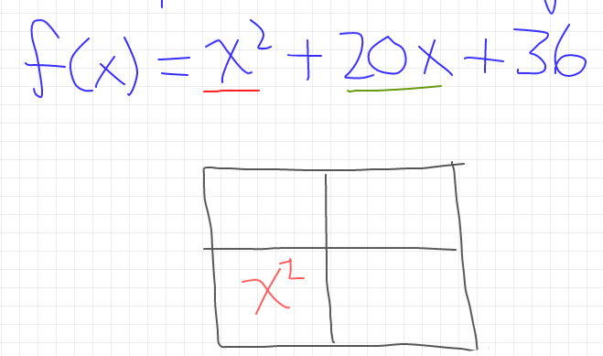
Example: $f(x)=x^{2}+20x + 36$

Step 1: Create a generic rectangle and put the $x^{2}$in the lower left corner.

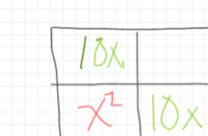
Step 2: Split the $20x$ in half and place each half in the generic rectangle.
**Why does it make sense to do this?

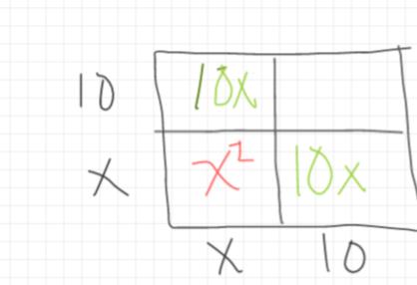
Step 3: Fill out the outside (base and height) of the generic rectangle.

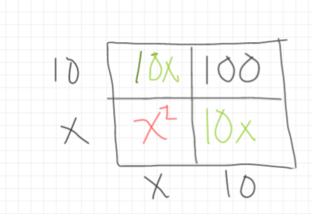
Step 4: Complete the inside of the generic rectangle using the outside values.

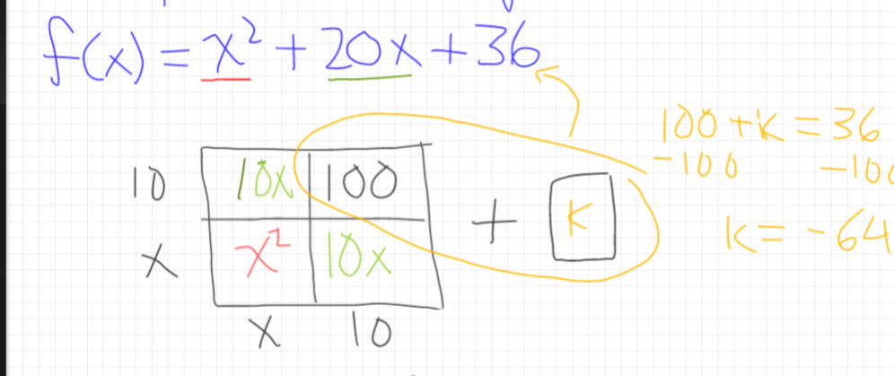

Step 5: Determine what value must be added to the generic rectangle to match the original function.

Step 5: Write the function in Graphing Form.
$f(x)=(x+10)^{2}-64$

