CCSS Algebra 4 Tangent on the Unit Circle
Recall that in a right triangle, $tan(θ)=\frac{opposite}{adjacent}$.
- Explain why, if $θ$ is a rotation on the unit circle, $tan(θ)=\frac{sin(θ)}{cos(θ)}$. Be specific.

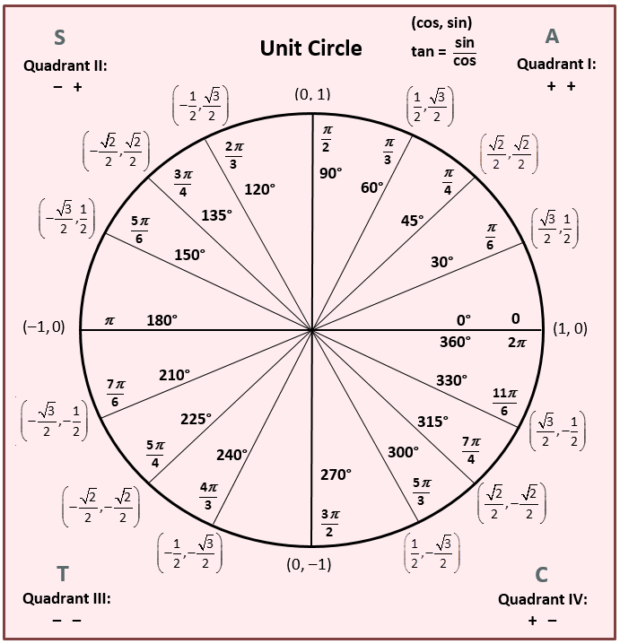
- Use the unit circle to find:
  - $tan({45}^{o})$

  - $tan({60}^{o})$

  - $tan(\frac{3π}{4})$

  - $tan({270}^{o})$

  - $tan(\frac{7π}{6})$

  - $tan(-{45}^{o})$

  - $tan({-120}^{o})$

  - $tan(-π)$

- Use the unit circle to solve each equation for $θ$:
  - $tan(θ)=\sqrt{3}, 0≤θ≤360$

  - $tan(θ)=0, -π≤θ≤π$

  - $tan(θ)=∞, -360≤θ≤0$

  - $tan(θ)=1, -360≤θ≤720$

- Fill in the following table. Use your answers to draw a graph of sine, cosine, and tangent.
$θ$ | 0 | 30 | 45 | 60 | 90
$cosθ$
$sinθ$
$tanθ$

$y=cosθ$  Domain:  Range:  Period: | 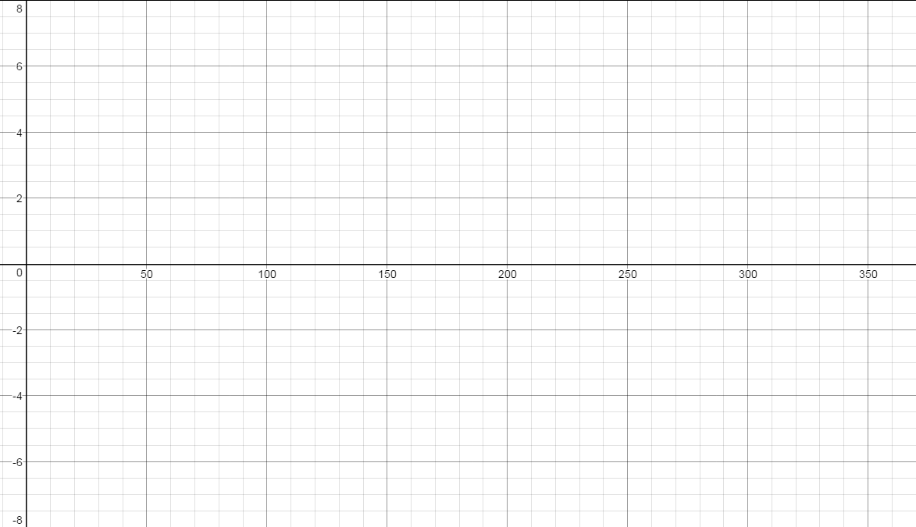
$y=sinθ$

Domain:

Range:

Period:
$y=tanθ$

Domain:

Range:

Period:

- Explain, using the unit circle, why the y-intercept for cosine is (0,1), but the y-intercept for sine AND tangent is (0,0).

- What Algebra 1/2 concept is equivalent to tangent? Why is the period for tangent DIFFERENT?

