CCSS Advanced Algebra 4 Trigonometric Functions (part 1) Name __________________________
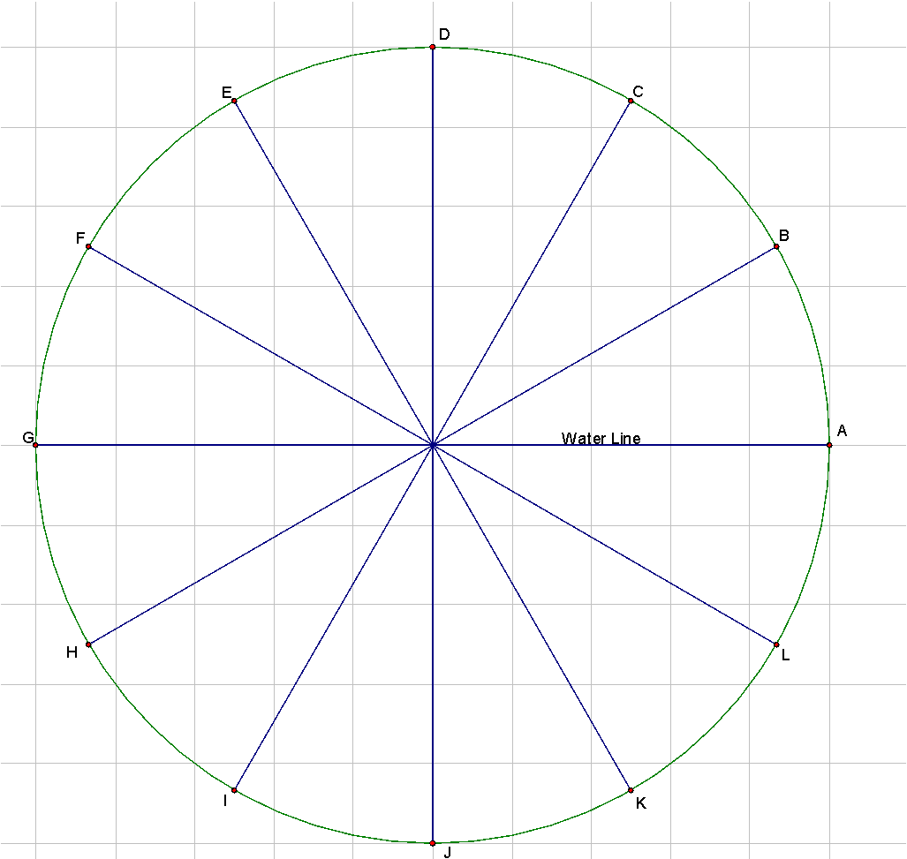
Kianna has a dream. She wants to design and build an amazing combination amusement park and zoo. One of the attractions she would use is a Ferris wheel that goes underwater so that riders can see aquatic animals for part of the ride and get a bird’s eye view of the park during the other half.

She builds a model of this ride in which the Ferris wheel has a 1-meter radius. The center of the wheel is at the water line.

The model Ferris wheel turns counterclockwise and makes one complete revolution every 6 minutes. Riders would board the Ferris wheel at point A.

1. Draw a right triangle inside the circle using the origin, the x-axis and the point labeled B.

2. What is the measure of the central angle (the angle at the origin) in the triangle you just drew? How many seconds would it take for a rider to move from point A to point B (recall that the Ferris wheel model takes 6 minutes for one complete cycle)?

3. Recall that in a right triangle, $sin θ=\frac{opposite leg}{hypotenuse}$, find the height of the Ferris wheel directly above the water line at point B.

4. Let x = time (in seconds) and y = Ferris wheel’s height above the water. Complete the table below to show the values of x and y at each lettered point in the figure (the letters are equally spaced along the circle).
 | A | B | C | D | E | F | G | H | I | J | K | L
x | 0
y
5. Use the table to sketch the graph of the Ferris wheel’s height as it rotates.

Compare your sketch with the graph of $y=sin x$ here.

6. Transformations with y=sin x..
Complete the Desmos: Trigonometric Graphing: Introduction to Amplitude and Vertical Shift (degrees)

7. Go to Ferris Wheel for Graphing Trig Functions. Adjust the sliders to answer the questions below (note that for this site, $h(t) = height of the red seat$ and $t = time in seconds$):
a. What is the highest point the Ferris Wheel reaches if a = 1? What is the lowest point the Ferris Wheel reaches when a = 1? highest and lowest points when a = 2? a = 3?

b. Why does it make sense that adjusting the vertical dilation (a) changes the highest and lowest points on the Ferris wheel?

c. How many seconds (or degrees) does it take the Ferris wheel to make a full rotation when b = 1? when b = 2? b =4?

d. What value of b would you use to make the Ferris Wheel complete a rotation in 60 seconds? 720 seconds? 240 seconds? Explain how you found your answers.

e. Why does it make sense that adjusting the horizontal dilation (b) changes the length of the rotation?

f. Reset a = 1 and b = 1. Adjust the slider for d (vertical translation). What effect does that have on the Ferris wheel? What value of d would you use to make sure the Ferris wheel is completely above the ground?

g. Reset d = 0. Adjust the slider for c (horizontal translation). What effect does that have on the red dot of the Ferris wheel? What value of c would you use if a rider boarded at the Ferris wheel’s lowest point?

7. For Trigonometric Functions like $h(t)=a sin(b(t+c))+d$, the following terms are used:
Amplitude (distance between the center of the function and the highest point)
Frequency (number of complete cycles that occur in a 360 degree interval)
Period (length of one full cycle)
Horizontal shift (left or right shift)
Vertical shift (up or down shift)
Midline (horizontal line through the center of the curve).
a. Explain the relationship between the terms above and the values of a, b, c, and d in the equation. Be specific as you will be including these in your notes.

b. For each equation shown, find the Period (length of one complete cycle).
$h(t)=sin(2t)$
$k(t)=sin(0.5t)$
$m(t)=sin(90t)$

c. What is the relationship between the Period and the Frequency of a trigonometric function?

