Unit 4: Curve Fitting 1/2/2019

- Directions: Sketch the function from the given the parent function, points (locator & pass-thru). Write the equation of the function. Try all the different types of functions.

Quadratic:
1) $y=x^{2}$, vertex (-4,3), passing thru (0,7)  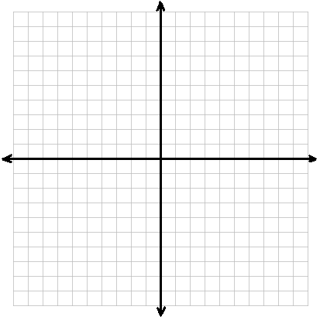 | 2) $y=x^{2}$, vertex (-5,2), passing thru (-3,3)
3) $y=x^{2}$, vertex (-5,-3), passing thru (-4,-5) | 4) $y=x^{2}$, vertex (-2,-1), passing thru (-4,3)

Radical (square & cube roots):
1) $y=\sqrt{x}$, y-int. (0,5), passing thru (4,7) | 2) $y=\sqrt{x}$, y-int. (0,-2), passing thru (4,0)
3) $y=\sqrt{x}$, min point (4,-2), passing thru (5,-1) | 4) $y=\sqrt[3]{x}$, y-int. (0,-2), passing thru (8,0)

Absolute Value

1) $y=|x|$, vertex (2,0), passing thru (6,4) | 2) $y=|x|$, vertex (0,-1), passing thru (-4,-5)
3) $y=|x|$, vertex (1.5, 0), passing thru (3,6) | 4) $y=|x|$, vertex (2,3), passing thru (1,-3)

Cubic (and two more radicals):
1) $y=x^{3}$, inflection point (4,-3), passing thru (5,-2) | 2) $y=x^{3}$, inflection point (-1,2), passing thru (0,3)
3) $y=\sqrt{x}$, min point (2,-1), passing thru (6,7) | 4) $y=\sqrt{x}$, max point (1,4), passing thru (3,3)

Equation Key:
Quadratic
1) $y=\frac{1}{4}(x+4)^{2}+3$ | 2) $y=\frac{1}{4}(x+5)^{2}+2$ | 3) $y=-2(x+5)^{2}-3$ | 4) $y=(x+2)^{2}-1$
Radical
1) $y=\sqrt{x}+5$ | 2) $y=\sqrt{x}-2$ | 3) $y=\sqrt{x-4}-2$ | 4) $y=\sqrt[3]{x}-2$
Absolute Value
1) $y=\left|x-2\right|$ | 2) $y=-\left|x\right|-1$ | 3) $y=2\left|2x-3\right|$ | 4) $y=-3\left|-2x=4\right|+3$
Cubic & more Radical
1) $y=(x-4)^{3}-3$ | 2) $y=(x+1)^{3}+2$ | 3) $y=4\sqrt{x-2}-1$ | 4) $y=-\frac{3}{4}\sqrt{x-1}+4$

