Algebra 3-4 Name: ________________________ Per:_____
Ch 1 Day 3 Domain and Range September 2/3, 2015

Find the domain and range for each graph. Then determine if the graph is a function.
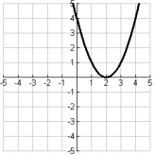  D:____________ R:____________  Function:________ | 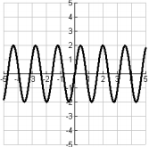  D:____________ R:____________  Function:________ | 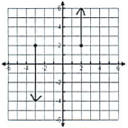  D:____________ R:____________  Function:________
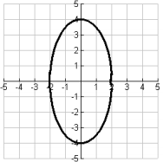  D:____________ R:____________  Function:________ | 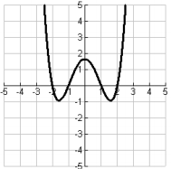  D:____________ R:____________  Function:________ | 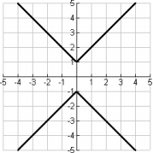  D:____________ R:____________  Function:________
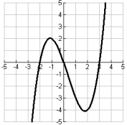  D:____________ R:____________  Function:________ | 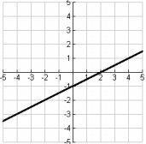  D:____________ R:____________  Function:________ | 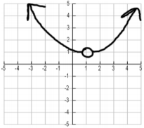  D:____________ R:____________  Function:________
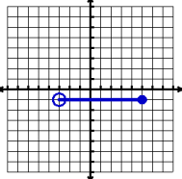  D:____________ R:____________  Function:________ | 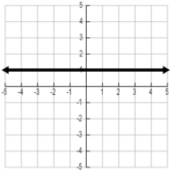  D:____________ R:____________  Function:________ | 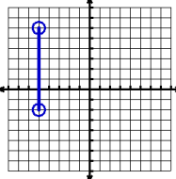  D:____________ R:____________  Function:________
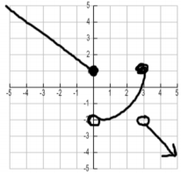  D:____________ R:____________  Function:________ | 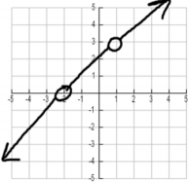  D:____________ R:____________  Function:________ | 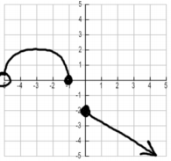  D:____________ R:____________  Function:________
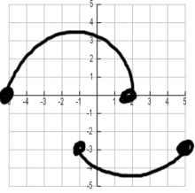  D:____________ R:____________  Function:________ | 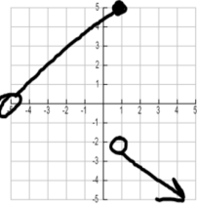  D:____________ R:____________  Function:________ | 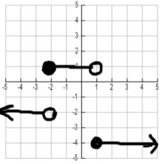  D:____________ R:____________  Function:________

Algebra 3-4 Name: ________________________ Per:_____
Ch 1 Day 3 Domain and Range September 2/3, 2015

Find the domain and range for each graph. Then determine if the graph is a function.
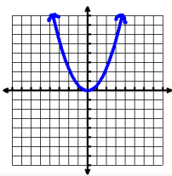  D:____________ R:____________  Function:________ | 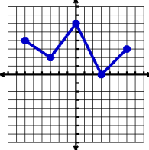  D:____________ R:____________  Function:________ | 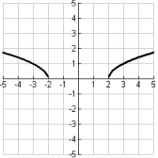  D:____________ R:____________  Function:________
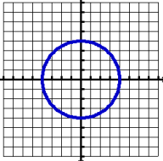  D:____________ R:____________  Function:________ | 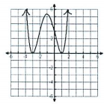  D:____________ R:____________  Function:________ | 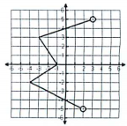  D:____________ R:____________  Function:________
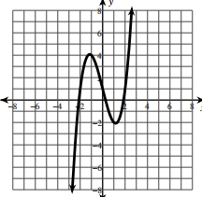  D:____________ R:____________  Function:________ | 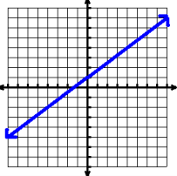  D:____________ R:____________  Function:________ | 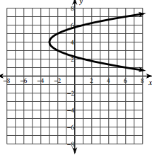  D:____________ R:____________  Function:________
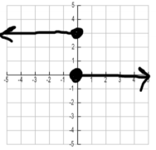  D:____________ R:____________  Function:________ | 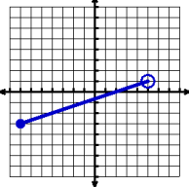  D:____________ R:____________  Function:________ | 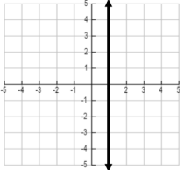  D:____________ R:____________  Function:________
D:____________ R:____________  Function:________ | D:____________ R:____________  Function:________ | D:____________ R:____________  Function:________
D:____________ R:____________  Function:________ | D:____________ R:____________  Function:________ | D:____________ R:____________  Function:________

