Algebra 2, Unit 9: Quadratics #26
Day #26: Multiplying

Now we’re going to learn about multiplying factors to change the form of a quadratic.

We’re going to use what’s called an AREA MODEL to multiply. How do you find the area of a rectangle?

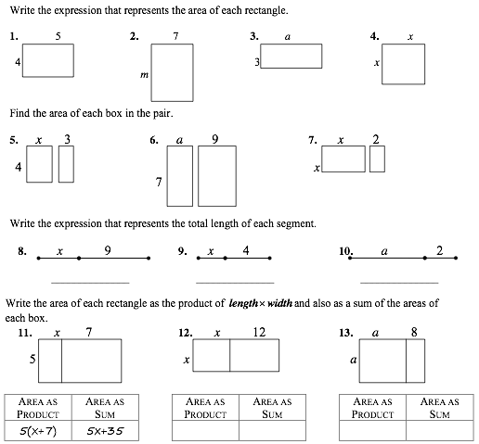

Vocabulary
Polynomial:

Binomial:

Multiplying Perfect Square Binomials

Remember the last couple classes we have learned about quadratic equations in this special form called Vertex Form: y = a(x - h)² + k. We’re going to explore the “(x - h)²” part and see how it can be represented another way.

Example 1: Let’s say we have a perfect square where each side is (x - 1) units in length.
First...How can I represent the area as a product?

Second, let’s find the area with an area model: Third, write the area as a simplified sum:

Example 2: Multiply out (x + 3)²

First, expand out (x + 3)² = _____________________________

Second, let’s find the area with an area model: Third, write the area as a simplified sum:

You Try:

Expand out each expression and then use an area model to find the product. Then simplify the expression. Notice any patterns.
1. (x + 1)² = 2. (x - 2)² = 3. (2x + 1)² =

Simplified: _________________ Simplified: _________________ Simplified: _________________

4. Generalize: What would (a + b)² simplify to when you multiply it out?

Rectangles
5. (3x + 2)(x – 1) 6. (3x – 2)(2x – 1) 7. (4x – 1)(2x + 3)

For the problems below, draw your own appropriate area model.
7. 3(x² + 5x + 7) 8. (x + 5)(x² +6x - 7)

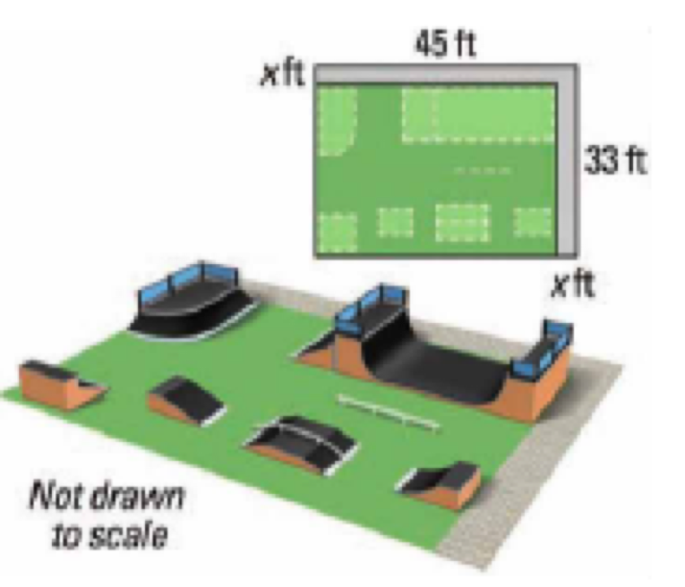
Solve real-world problems:
1. You are designing a rectangular skateboard park on a lot that is on the corner of a city block. The park will have a walkway along two sides. The dimensions of the lot and the walkway are shown in the diagram.

a. Write a polynomial that represents the area of the skateboard park.

b. What is the area of the park if the walkway is 3 feet wide?

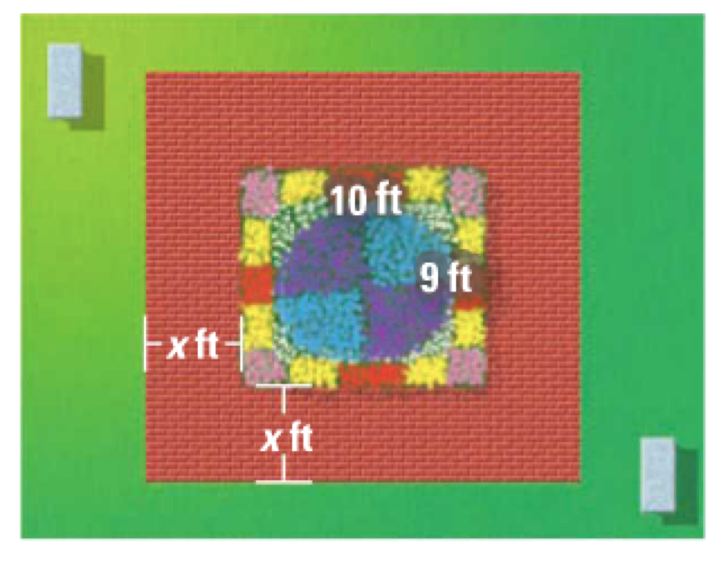
2. You are planning to build a brick walkway that surrounds a rectangular garden, as shown. The width of the walkway around the garden is the same on every side.

a. Write a polynomial that represents the combined area of the garden and the walkway.

b. Find the combined area when the width of the walkway is 4 feet.

3. The dimensions of a rectangle are x + 3 and x + 2. Which expression represents the area of the rectangle?
a) x² + 6 b) x² + 5x + 6 c) x² + 6x + 6 d) x² + 6x

Explain how you chose your solution to problem 3.

