Advanced Algebra 3 Name:__________
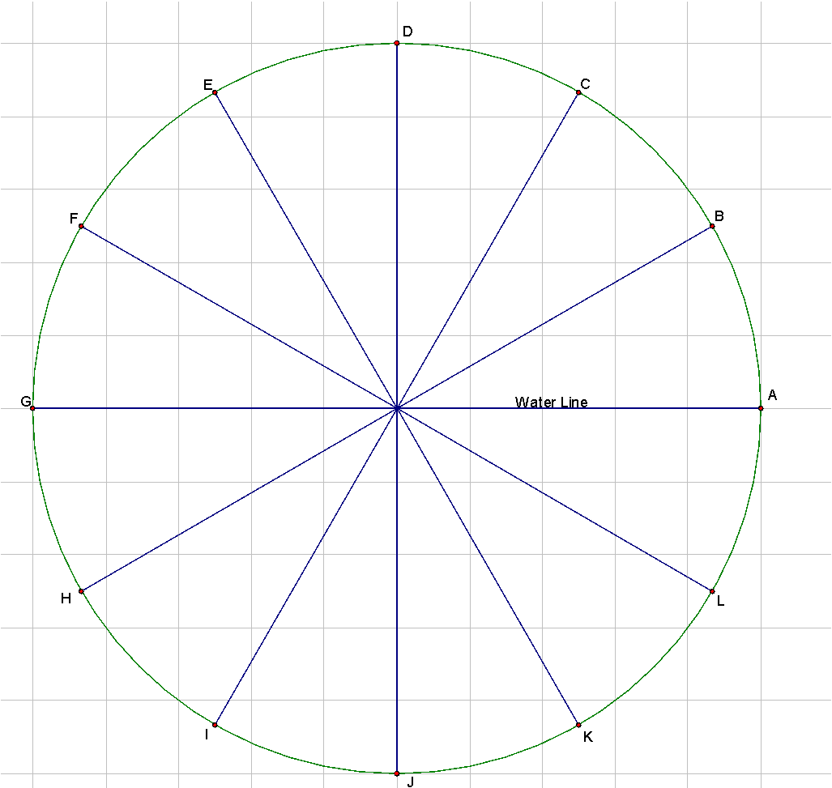
Remember that Kianna’s Ferris Wheel had a radius of 1 meter and makes a full rotation (counter-clockwise) in 6 minutes.

1. Let x = time (in seconds) and y = Ferris wheel’s height above the water. Complete the table below to show the values of x and y at each lettered point in the figure (the letters are equally spaced along the circle).

After you complete the table, sketch a graph on the axes below. Recall that because $sin θ=\frac{opposite leg}{hypotenuse}$, and the radius of the circle is one, that $sin θ=y$.

 | A | B | C | D | E | F | G | H | I | J | K | L
$θ$ | 0 | 30
y

2. For what values of $θ$will Kianna be above the ground? For what values of $θ$ will she be underwater?

3. Kianna decides that she wants MORE of her Ferris Wheel underwater because the aquatic life is super cool to look at. She decides to LOWER the midline of her Ferris Wheel by $\frac{1}{2}$ a meter. In other words, she builds the model $y=sin θ-$$\frac{1}{2}$ . Fill out the table below, then use your answers to graph $y=sin θ-$$\frac{1}{2}$
 | A | B | C | D | E | F | G | H | I | J | K | L
$θ$ | 0
y

4. For what values of $θ$will Kianna be above the ground? For what values of $θ$ will she be underwater?

5. What would Kianna’s equation be if she wanted her model a ½ meter HIGHER? Describe the values of $θ$ for which she will be above/below the ground.
6. Kianna’s little brother is more of a thrill seeker. He wants to go fast. He wants his Ferris Wheel to go TWICE as fast as his sister’s. Which of the graphs below represents Kianna’s brother’s model? How do you know?
Equation:$y=sin(θ+2)$ | Equation:$y=2sin(θ)$
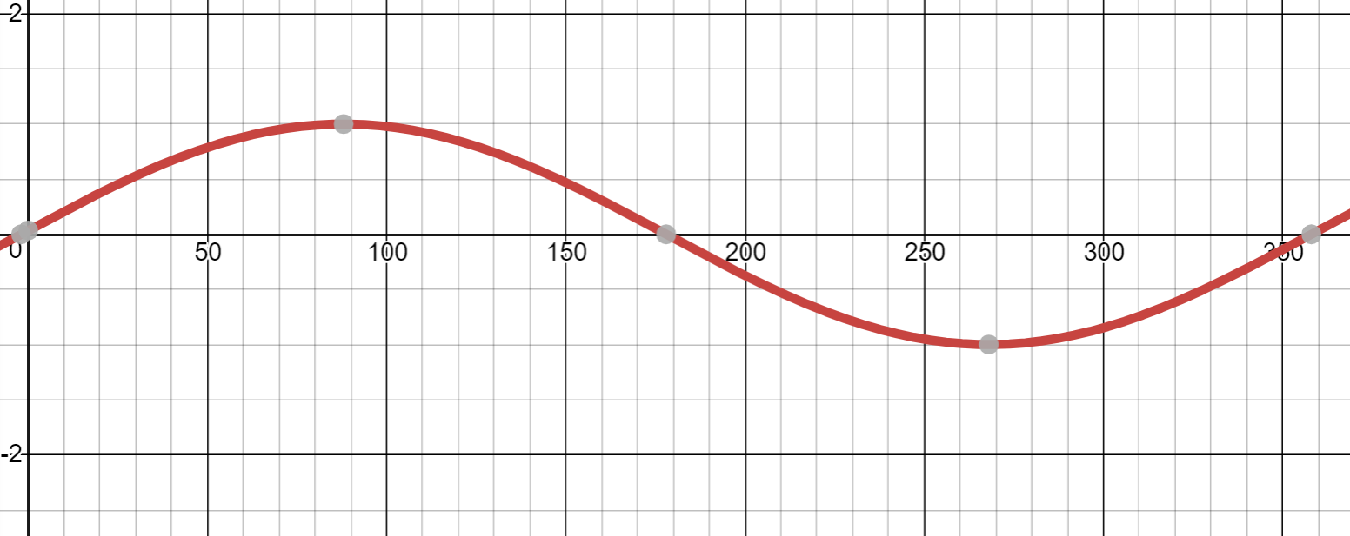 | 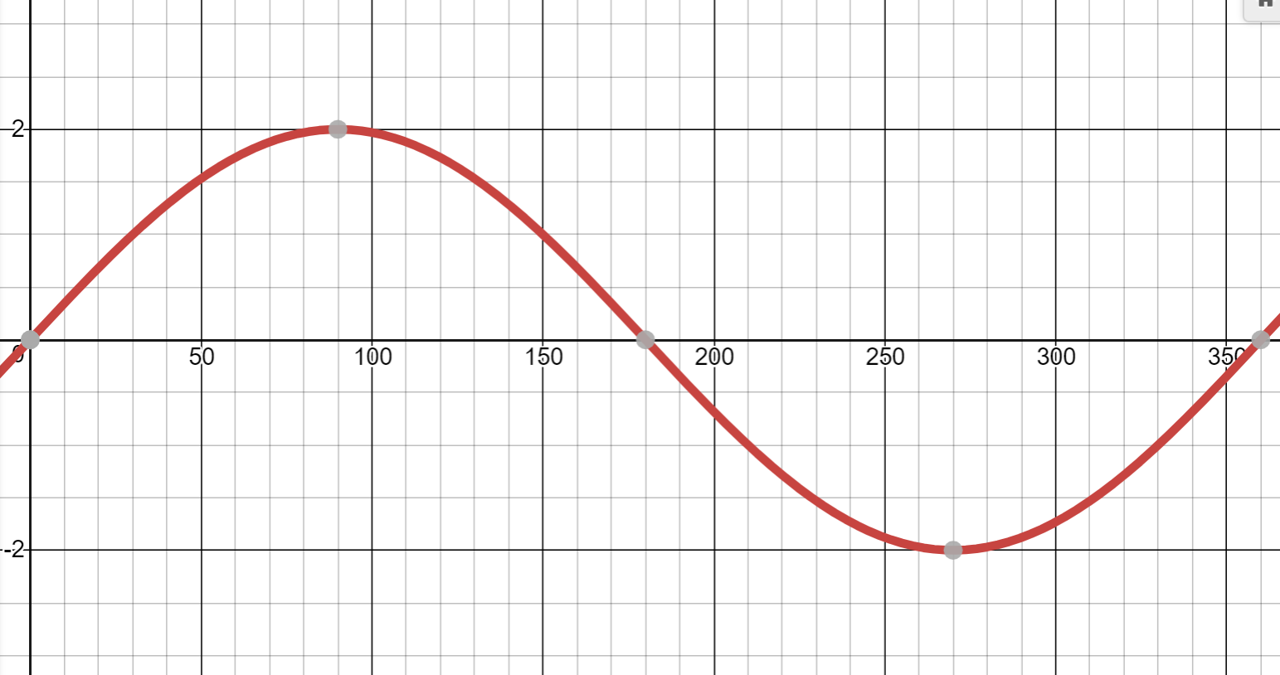
Equation:$y=sin(θ)+2$ | Equation:$y=sin(2θ)$
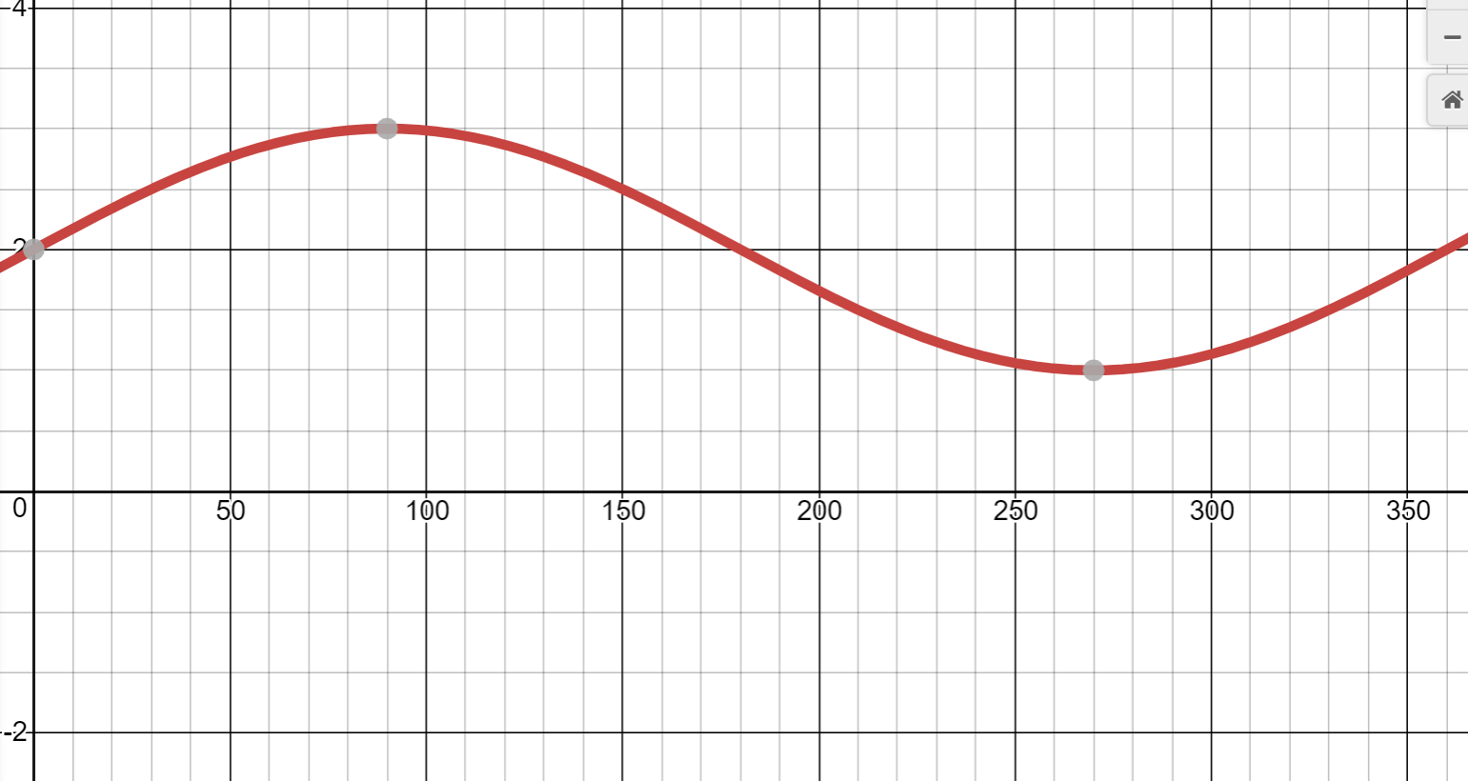 | 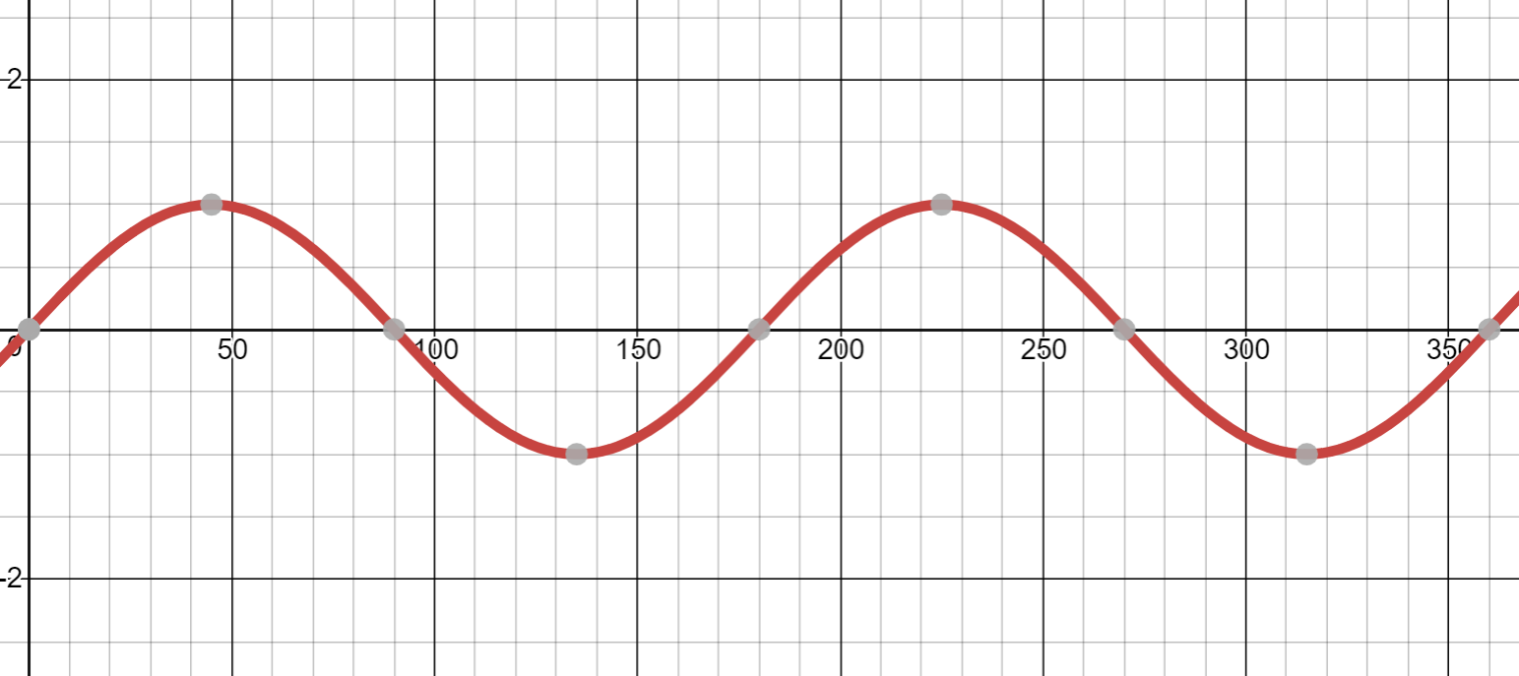

7. How long does it take Kianna’s wheel to do a full rotation (in seconds)? How long does it take her brother’s wheel to do a full rotation (in seconds)?

8. Kianna’s brother is not satisfied with going TWICE as fast (after all, 3 minutes is still a pretty slow revolution). He wants a new Ferris Wheel that goes THRICE (three times) as fast. Write the equation of his Ferris Wheel. Describe the values of $θ$ for which he will be above/below the ground.

9. The time it takes to turn a full revolution is called the PERIOD. Write a note about how the period relates to the equation of the Ferris Wheel.
10. Mixed Practice: Describe as much information about each Ferris Wheel as you can. Make sure to identify the: 1. Radius, 2. Period, 3. Midline. Bonus for giving the values of $θ$ for which she will be above/below the ground. Sketch a graph.
- $y=10sinθ$

- $y=2sinθ+10$

- $y=5sin(10θ)$

- $y=10sin(4θ)-5$

- $y=3sin(0.5θ)+10$

11. Mixed Practice: Describe as much information about each Ferris Wheel as you can. Make sure to identify the: 1. Radius, 2. Period, 3. Midline. Bonus for giving the values of $θ$ for which she will be above/below the ground. Write the Equation.
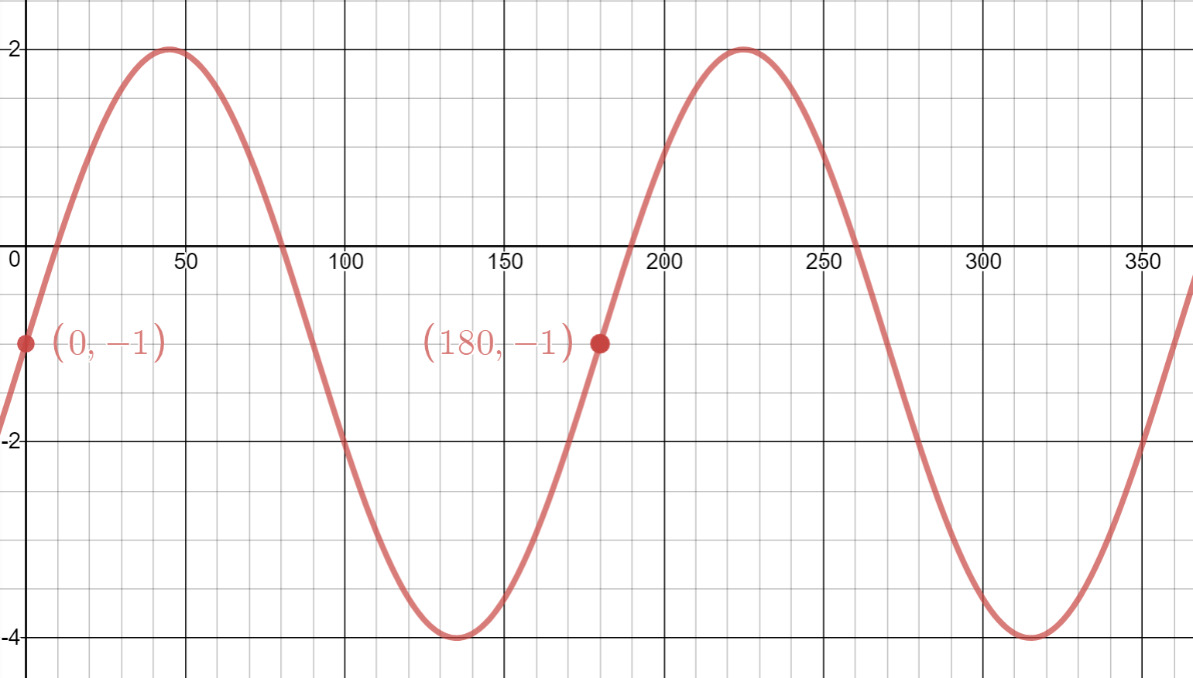 | 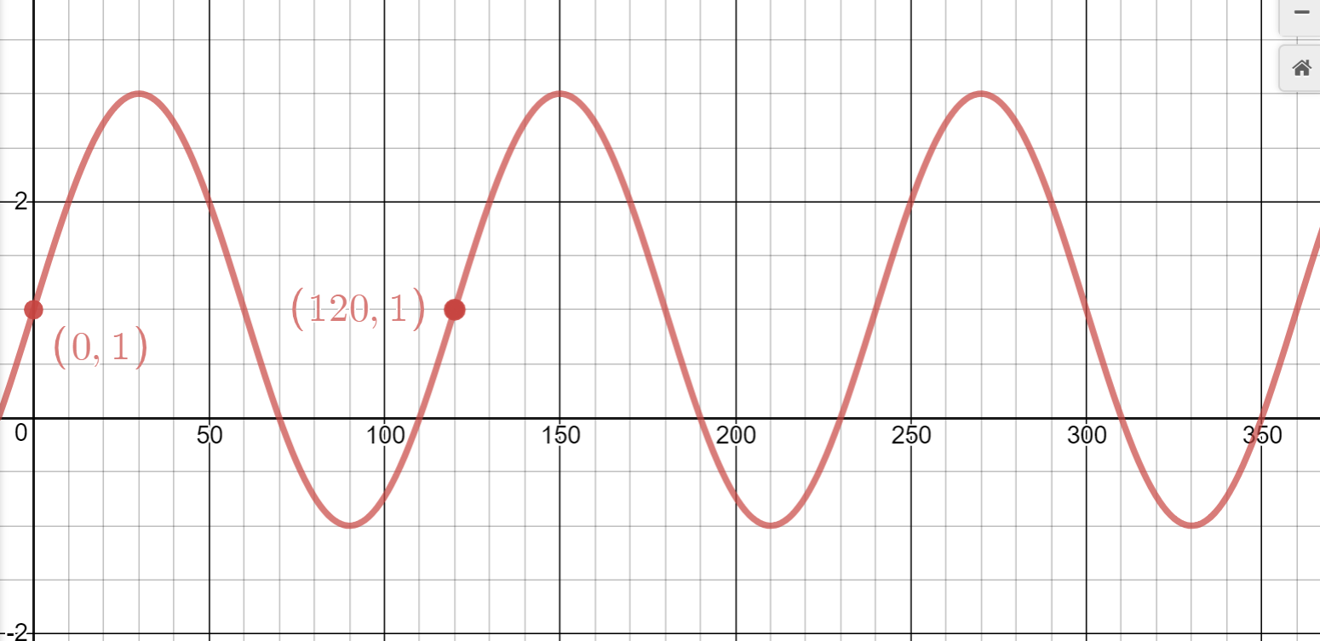
Equation | Equation

