CCSS Algebra ½ Name:___________

Point-Slope Form: What's the Point?

Mr. Ward joined the Algebra team a little late, so he is trying to get caught up on some of the activities the Algebra teachers have been doing. Please help Mr. Ward understand some of the activities that we have done over the last few units, and learn a little new math along the way.

Ropes and Slopes:

Mr. Ward asks the other Algebra teachers about the Ropes and Slopes activity. They give him this piece of rope along with the following information:

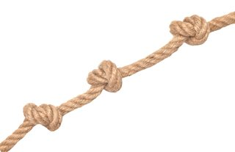 | - Every knot tied decreases the length of the rope by 2.5 cm.  - There are 3 total knots in the rope  - The length of the rope (WITH THE 3 KNOTS) is 17.5 cm.

- We normally write linear equations in the form $y=mx+b$. What do the letters m and b represent in a linear equation? What do they represent in the context of Ropes and Slopes?

- Which one of the following numbers is the SLOPE of the rope? (Circle one) Explain.

a. 17.5 b. -2.5 c. 2.5 d. -3 e. -17.5 f. 3

- Do you know the y-intercept? Can you figure it out? What does it mean in the context of Ropes and Slopes?

- Consider the equation: $y=-2.5(x-3)+17.5$, where y = the length of the rope with x knots tied. Use the distributive property on the equation. What do you notice?

- Equations in the form $y=-2.5(x-3)+17.5$are called equations in Point-Slope Form. The point in the equation is (3, 17.5) and the slope is -2.5. What do the 3 and the 17.5 tell you about the rope?

- Mr. Ward ties another knot in the rope. What is the length of the rope with 4 knots in it? Use the slope to determine your answer.

- Mr. Ward writes the equation $y=-2.5(x-4)+15$, because it seems to match the way the equation in problem 5 was written. Use the distributive property on this new equation. What do you notice? What do the 4 and the 20 tell you about the rope?

- Ms. Muhs sees what Mr. Ward is doing, but she is a little confused about how to write equations in Point-Slope Form. She ties another knot in the rope and tries to write an equation like in problems 5 and 7. Which of the following equations is correct? How do you know?
$y=2.5(x-5)+12.5$ | $y=-2.5(x+5)+12.5$ | $y=-2.5(x-5)+12.5$ | $y=-2.5(x-5)-12.5$

- Ms. Muhs notices that the structure of the equation is the same, and that it doesn’t seem to matter how many knots are tied in the rope. She makes the following table, but a few entries are left blank. Help Ms. Muhs finish her table.

Point | (6,10) | (7,7.5) |  | (9,2.5)
Equation | $y=-2.5(x-6)+10$ |  | $y=-2.5(x-8)+5$

- Mr. Maurer thinks that there are two very important points on the graph of a line: the x-intercept and the y-intercept. He also knows the rope is 25 cm long without any knots in it, and that the rope would (theoretically) have a length of 0 with 10 knots. Which one of those numbers is the x-intercept? How do you know? Which is the y-intercept?

Stacking Cups
Mr. Ward is trying to determine how many red solo cups it would take to build a tower as tall as Mr. Maurer (who is 6 foot 3 inches tall). Mr. Ward builds a stack of 3 cups and a stack of 7 cups before getting frustrated and knocking it all over. Mr. Maurer suggests using Point-Slope form to answer the question.

- The stack of 3 cups was 5.5 inches tall. The stack of 7 cups was 6.5 inches tall. Use this information to determine the slope and write a sentence explaining what the slope means in the context of stacking cups (use the word PER in your sentence).

Slope =
Sentence:

- Based on the Ropes and Slopes questions from earlier, Mr. Ward believes that he can write the equation for the height of the stack in point-slope form. Identify which TWO of the following equations correctly model the height of the stack. Let h(x) represent the height of the stack of cups (in inches) and x represent the number of cups in the stack.
$h(x)=2.5(x+3)+5.5$ | $h(x)=-2.5(x+3)+5.5$ | $h(x)=2.5(x-3)+5.5$
$h(x)=2.5(x+7)+6.5$ | $h(x)=2.5(x-7)+6.5$ | $h(x)=-2.5(x+7)+6.5$

- Use the distributive property on BOTH of the equations you identified in question 2. You should get the same answer for both equations. Write all THREE equations in the table below.

Point - Slope using (3,5.5) | Point - Slope using (7,6.5) | Slope-Intercept using (0,b)
$h(x)=$ | $h(x)=$ | $h(x)=$

- Calculate h(10) using each of the equations and write a sentence explaining what your answer means in the context of stacking cups.

h(10) =
Sentence:

- Calculate how many cups it would take to be as tall as Mr. Maurer.

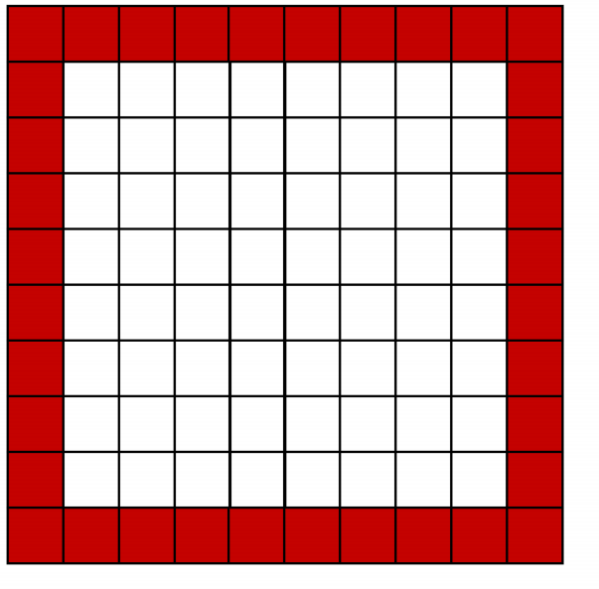
Tile Patterns
Remember the border problem? This was called figure 10.

- There are 36 tiles in the border of figure 10. Every additional figure increases the number of border tiles by 4. Write an equation using point-slope form to model the number of border tiles in any figure.

- The equation in slope-intercept form is $b(x)=4x-4$, where b(x) represents the number of border tiles, and x represents the side length of the outer square. VERIFY that there are 36 tiles in figure 10 by calculating b(10). Do the same for your point-slope equation from problem 1.

- Solve the equation $b(x)=100$using your slope-intercept form equation and VERIFY your answer by solving $b(x)=100$with your point-slope form equation. Write a complete sentence that puts your answer in the context of the problem.

- What is $b(0)$? Does your answer make sense?

The Big Race (revisited)
Mr. Ward is still mad that the other algebra teachers left him out of the first three preliminary heats in The Big Race. He challenges the algebra teachers to another race. Use the following information to write an equation for each runner. Then, determine who wins the race.
- I(x). Ian Maurer can run 21 yards every 3 seconds. He is feeling pretty cocky, so he waits for 3 seconds before he starts running from the starting line.
- E(x). Ellen Maiden can run 16 yards every 3 seconds. She was the winner in the last big race so she takes off at the starting gun from the starting line. No head starts for her.
- C(x). Chelsea Muhs can run 21 yards every 4 seconds. She is pretty heated about not winning many of the previous heats. She requests a 5 yard head start, and starts running at the starting gun.
- J(x). Jason Ward can run 29 yards every 5 seconds. He requests to have a 10 yard head start, but he is still arguing with Mr. Maurer about leaving him off the other activity, so he takes 3 seconds after the starting gun to start running.

