Advanced Algebra 4 Name:____________

Trig Practice and Review Packet

You will turn in this packet for a grade. Some of the answers are online. Work with others, check the solutions, and utilize tutoring to get the problems done correctly.

OLD STUFF: Units 1, 2, 4
1. a. Parent Absolute Value function ($y=|x|$) is shifted 2 units right and 4 units down.
i. Write the transformed function

ii. Find the x-intercepts of this function algebraically.

iii. Without graphing, what would be the y-intercept(s) of the INVERSE of this
function? Explain how you know.

b. Parent Square Root function ($y=\sqrt{x})$ is reflected over the y-axis and stretched
vertically by a factor of 3 and shifted up 48 units.
i. Write the transformed function

ii. Find the x-intercepts of this function algebraically.

iii. Find the inverse of this function algebraically.

d. Parent Quadratic function ($y=x^{2}$) is reflected over the x-axis, stretched
vertically by a factor of 10 and shifted left 1 unit and shifted up 1.6 units.
i. Write the transformed function

ii. Find the x-intercepts of this function algebraically.

3. The graph shows the function $h(x)$. Sketch each graph below
and write the domain and range of the new relation.
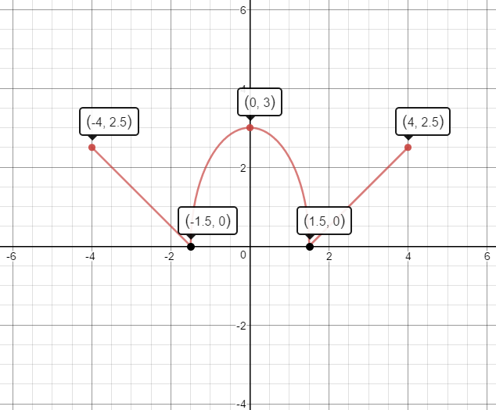
a. $h(x-2)+1$ b. $-h(x)-1$

c. $-h(x+2)$ d.$h^{-1}(x)$

4.
Factor $f(x)=x^{2}+16x+60$ | Factor $g(x)=x^{2}+10x-11$ | Factor $h(x)=x^{2}-5x+6$
Find the x-intercepts of $f(x)=x^{2}+16x+60$ | Find the x-intercepts of $g(x)=x^{2}+10x-11$ | Find the x-intercepts of $h(x)=x^{2}-5x+6$
Complete the square for $f(x)=x^{2}+16x+60$ | Complete the square for $g(x)=x^{2}+10x-11$ | Complete the square for $h(x)=x^{2}-5x+6$
Solve the inequality $x^{2}+16x+60>0$ | Solve the inequality $x^{2}+10x-11≤0$ | Solve the inequality $x^{2}-5x+6≥0$

4. During the finals of the Punkin’ Chunkin’ Championship, CC and Ahmed’s catapults had
the following results:
CC: placed her catapult on the 5 yard line; her pumpkin landed at the 45 yard line and
reached a maximum height of 4 yards.

Ahmed: placed his catapult on the 10 yard line; his pumpkin reached a maximum
height of 6.48 meters directly above the 28 yard line.

Write Quadratic Functions for both CC and Ahmed’s pumpkin paths. Sketch a graph for
each pumpkin and label as many points as you know.

OLD STUFF: Unit 3
- Write the equation of an exponential function from a table, graph or description.
1. Write the equation of each exponential function described below:
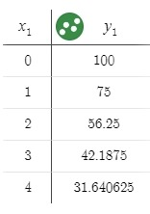
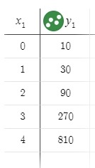
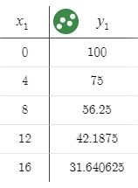
a. b. c.

- Solve equations using exponents and logarithms.
2. Solve each equation below for x. Check your answer:
a. $7(3)^{x}+8=61$ b. $3 log_{5}(4x-1)=21$

c. $5(10)^{x-3}=35$ d. $-8log_{2}(3x)= -80$

- Write the inverse of exponential and logarithmic functions.
3. Find the inverse of each function below:
a. $g(x)=5(11)^{x-1}$ b. $h(x)=log_{8}(x)-2$

OLD STUFF: Unit 5
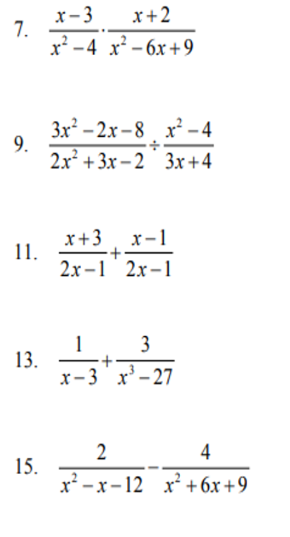
Simplify each expression. Identify any domain restrictions

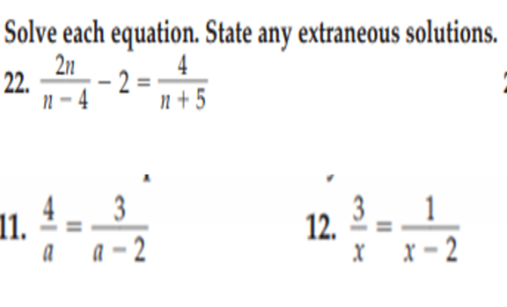
OLD STUFF: Unit 6
Simplify each polynomial expression. Write the solution in Standard Form:

a. $(4x^{3}-10x^{2}+2x-7)+(3-2x-5x^{2}-7x^{3})$ b. $(4x^{3}-10x^{2}+2x-7)-(3-2x-5x^{2}-7x^{3})$

c. $(2x-7)(3x^{2}-5x+1)$ d. $\frac{6x^{3}-29x^{2}+32x-14}{2x-7}$

3. Write a polynomial function in Factored Form for each description below:
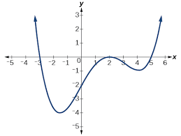
a. x-intercepts at (3,0), (4,0), (5,0) and a degree of 5. b.

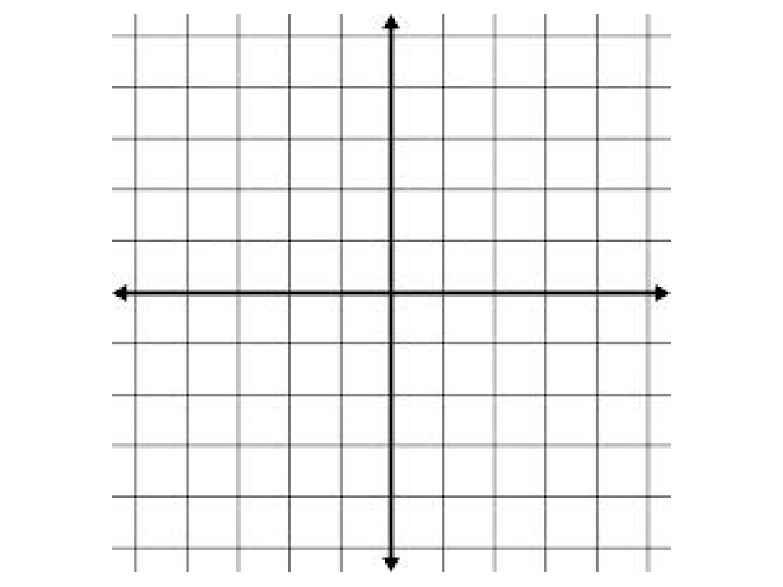
4. a. Factor $t(x)=(x^{2}+2x+1)(x^{2}-1)$.

b. Identify the x-intercepts and state the multiplicity of each root.

c. Use the x-intercepts and multiplicities to sketch the graph of $t(x)$.
d. Describe what happens to $t(x)$ when $x→-∞$
and when $x→∞$.

OLD STUFF: Unit 7
ADD, SUBTRACT and MULTIPLY Complex Numbers

a. $(10-2i)+(3-i)$ b. $(10-2i)-(3-i)$

c. $(10-2i)(3-i)$ d. $(10-2i)(10+2i)$

e. $(a+bi) +(a-bi)$ f. $(a+bi) -(a-bi)$

g. $(a+bi) (a-bi)$ h. $(-a+bi) (-a-bi)$

Use the definition of “i” to compute powers of “i”
a. $i^{2}=$ b. $i^{3}=$ c. $i^{4}=$ d. $i^{5}=$

e. $i^{8}=$ f. $i^{12}=$ g. $i^{21}=$ h. $i^{4x}=$

Write in words what the pattern is for computing powers of “i”

Use the Quadratic Formula to find all roots of each equation.
a. $x^{2}+4x+5=0$ b. $-3x^{2}-2x-5=0$ c.$4x^{2}+3=5x^{2}+4$

Explain why complex roots ALWAYS come in conjugate pairs (Hint: QF).

Write the polynomial with roots of $x=2+3i$, $x=2-3i$, and $x=-1$in STANDARD FORM
NEW STUFF: Unit 8
1. Use a unit circle to find:

$θ$ | $sinθ$ | $cosθ$ | $tanθ$
60
405
750
-45
-150

2. Use the unit circle to solve:
a. $cos(θ^{o})= \frac{\sqrt{3}}{2}, {-360}^{o}≤θ^{o}≤360^{o}$

b. $sin(θ^{o})= -\frac{1}{2}, 0≤x≤720$

c. $tan(θ^{o})= 1, 360≤θ^{o}≤720$

3. Consider the function: $f(x)=11 sin(9x)-14$
a. What is the amplitude of the function?

b. What is the midline of the function?

c. What is the range of the function (in the form $\#≤y≤\#$)?

d. What is the period of the function in degrees?

e. What is the period of the function in radians?

4. Write the equation of the graph shown below. Indicate whether you are using degrees or radians.
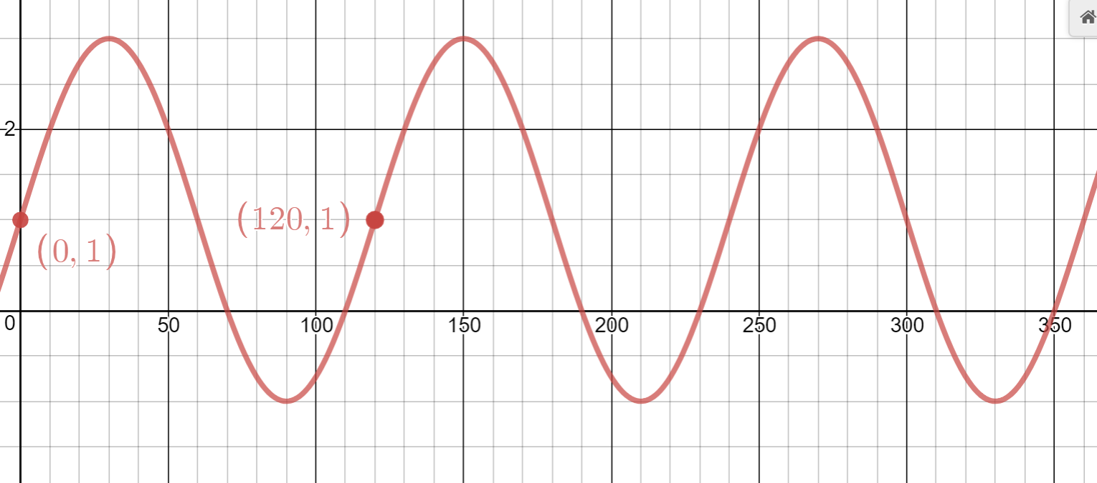

5. Write the equation of the graph shown below. Indicate whether you are using degrees or radians.

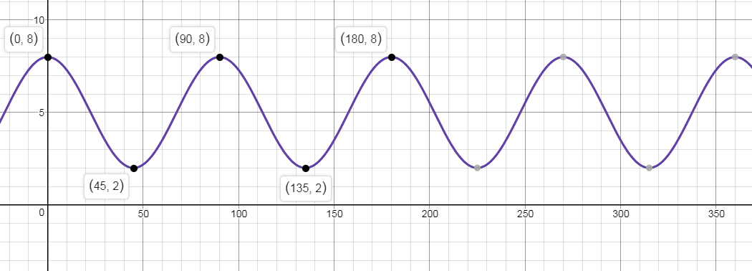

Fill in each triangle as much as possible.
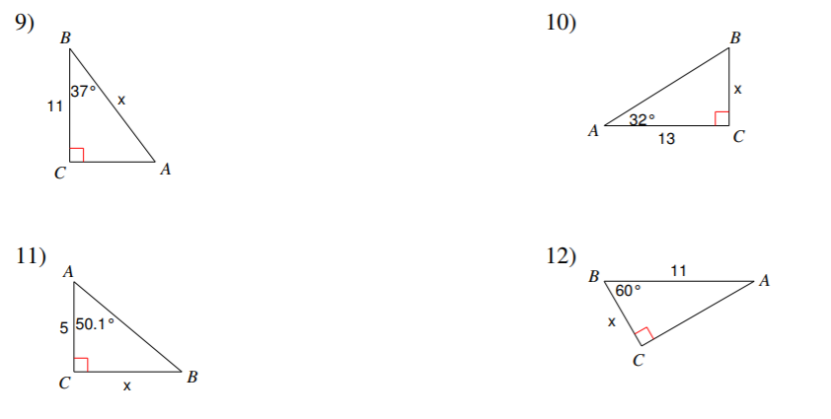
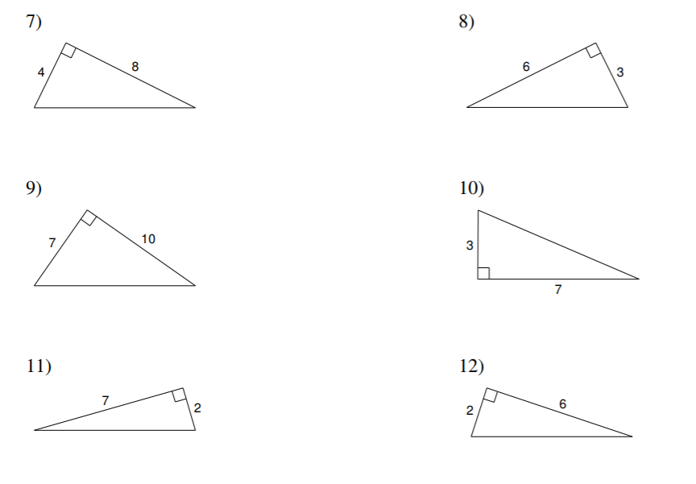
Write a note: When do you use SohCahToa? When do you use Pythagorean Theorem? Include examples.

