Algebra 3-4 Name: ________________________ Per:_____

Ch 8 Day 6 Transforming Trig Graphs - Frequency Date: __________________________

We have seen how changing the equation of the sine and cosine functions affects its graph using a, h and k. However, there is one more parameter for trig. functions, ***b (frequency).***

**The general equations are:  **

**1)** If***b*****≠ 1,** we must consider the frequency and period of the graph. Find the amplitude, period, and frequency of each graph. Then write its equation.

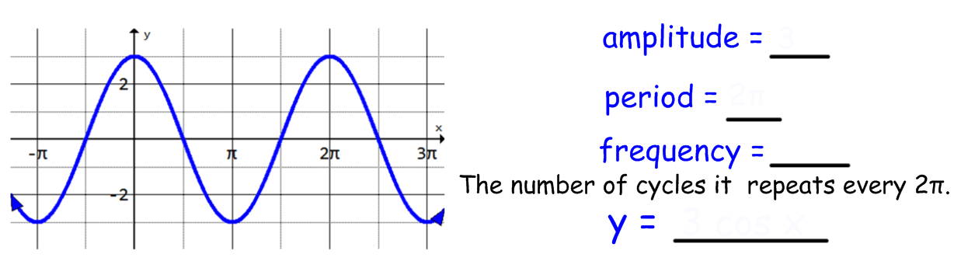

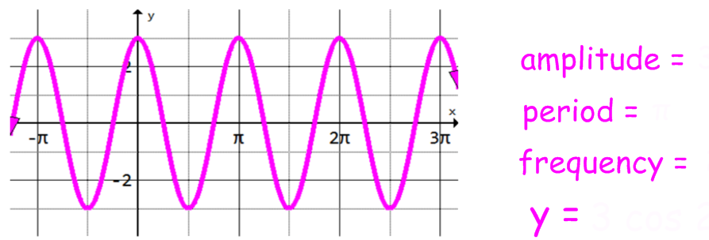

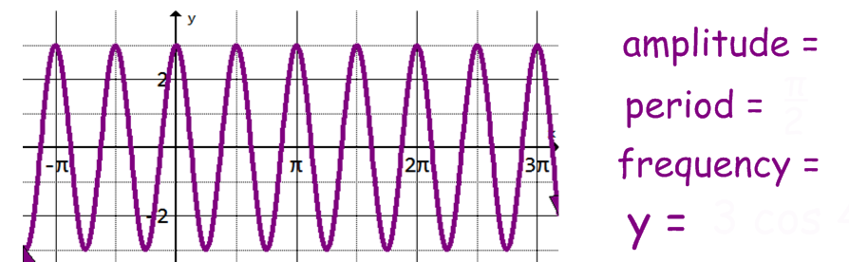

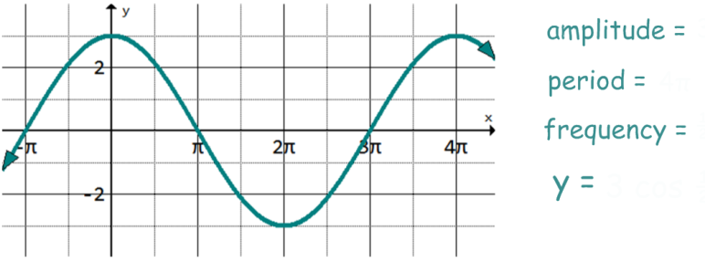

**2)** Given each period, find the frequency. Then write the equation of a **sine** function.

1. period =  frequency = ________ equation: ________________________
2. period =  frequency = ________ equation: ________________________
3. period =  frequency = ________ equation: ________________________
4. period =  frequency = ________ equation: ________________________

**3)** Graph each equation (label scale on axes).

**a)**  **b)** 

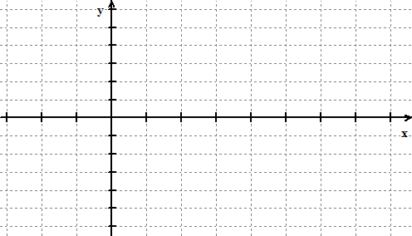 

**c)**  **d)** 

 

**4)** Write an equation for each of these graphs.

**a)** **b)**

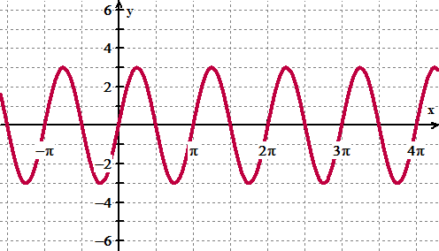 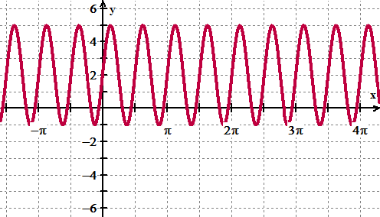

**c)** **d)**

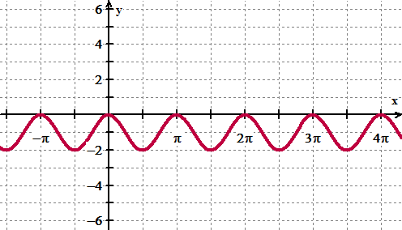 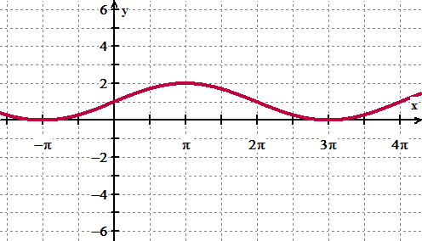

**5)** Graph each equation (label scale on axes).

**a)**  **b)** 



**c)**  **d)**  

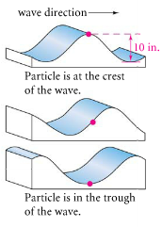6) The figures at right show the vertical motion of a water molecule as a waves moves by. Suppose 10 inch waves occur every 4 seconds. Write an equation that models the height of the water molecule as it moves from crest to crest.

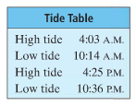

7) The table at the right shows the times for high tide and low tide. The markings on the side of a local pier showed a high tide of 7 feet and a low tide of 4 feet on the previous day.

1. What is the average depth of water at the pier?
2. What is the amplitude of the variation from the average depth?
3. How long is one cycle of the tide?
4. Write a trig equation that models the depth of the water in relation to the time of day.
5. Suppose your boat needs at least 5 feet of water to approach or leave the pier. Between what times can you come and go?