Algebra 3-4 Name: ________________________ Per:_____

Unit 3 Review: Functions & Inverses Date: _________________________

1. Tell whether the following are functions. Explain.

$$\left\{\left(-2, 5\right), \left(-1, 1\right), \left(3, 1\right), \left(-1, -2\right)\right\}$$

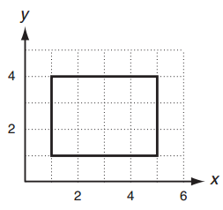

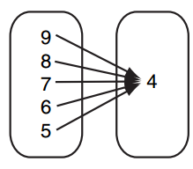

1. Find domain and range of the given graphs below. State if each graph is a function:

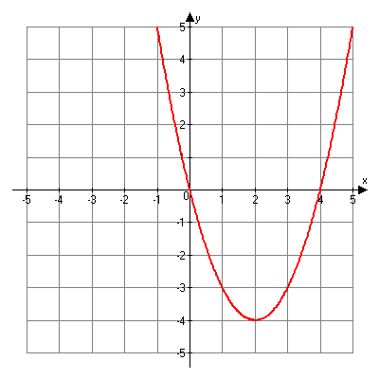 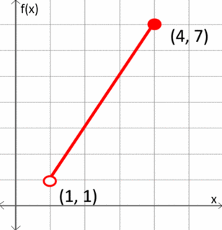

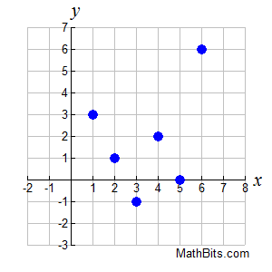 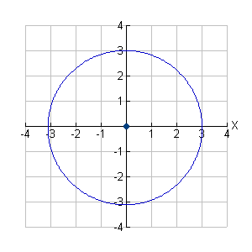

1. **The following graph completely defines f(x).**

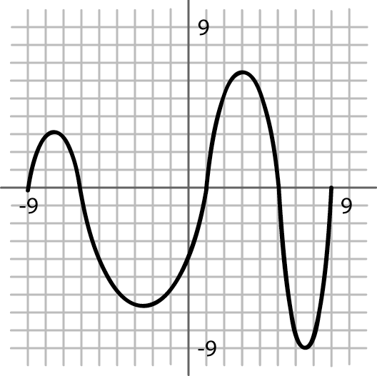

a. Evaluate b. Evaluate

c. Solve 

1. Use the functions, ,  to answer the questions below.

a. Evaluate *f(-7)* b. Solve *h(x)* = -7 c. Evaluate *g(-4)*

d. Solve *g(x)* = 1 e. Solve *f(x)* = -5 f. Evaluate *h(-1)*

g. Find the domain of *f(x)*. h. Find the range of *h(x)* i. Find the range of g*(x)*

1. Given two function machines $f\left(x\right)=x^{2}-1$ and $g\left(x\right)=3\left(x+2\right)$.
2. If the two machines are connected so that $f\left(x\right)$ comes first, and 5 is dropped in, what comes out? (This is finding $g\left(f\left(5\right)\right)$)
3. If the two machines are connected so that $g\left(x\right)$ comes first, and 5 is dropped in, what comes out? (This is finding $f\left(g\left(5\right)\right)$)
4. Find the inverse of the following functions:
$y=\frac{1}{2}x-3$

$g\left(x\right)=\sqrt[3]{x}+3$

$h\left(x\right)=\frac{7x+18}{2}$

$f\left(x\right)=2x^{4}+5$

5. Given two function $f\left(x\right)=\frac{2}{x-7}$ and $g\left(x\right)=2x+5$ calculate:
$g\left(3\right)=$

$f\left(10\right)=$

$f\left(g\left(2\right)\right)=$

$g\left(f\left(11\right)\right)=$

6. Find and verify the inverse of the following functions:

$f\left(x\right)=3\left(4x+5\right)-1$

$g\left(x\right)=\frac{\sqrt[3]{x+4}}{2}$

|  |  |
| --- | --- |
| Graph $f\left(x\right)=\sqrt{x-3}$ | Find the inverse. |
| Fill out the table:   |  |  |  | | --- | --- | --- | |  | Original | Inverse | | Domain |  |  | | Range |  |  | | x-intercept |  |  | | y-intercept |  |  | | Why isn’t the inverse a full parabola with a domain of $(-∞,∞)$? |

10.

|  |  |  |  |  |  |  |  |  |  |  |  |  |  |  |  |  |
| --- | --- | --- | --- | --- | --- | --- | --- | --- | --- | --- | --- | --- | --- | --- | --- | --- |
| Think about the function $f\left(x\right)={(x+2)}^{2}-3$. Will its inverse be a function? Why not? | Fill out the table:   |  |  |  | | --- | --- | --- | |  | Original | Inverse | | Domain |  |  | | Range |  |  | | x-intercept |  |  | | y-intercept |  |  | |
| Graph $f\left(x\right)={(x+2)}^{2}-3$ with its restricted domain. | Find the inverse. |