Algebra 3-4 Name: ____________________________
Unit 7 Day 0 HW – Quadratic Formula Date:__________________ Period: ____
Many quadratic equations can be solved by graphing, factoring, taking the square root, or completing the square. Some cannot be solved using any of these methods, but you can always use the QUADRATIC FORMULA to solve any quadratic equation.
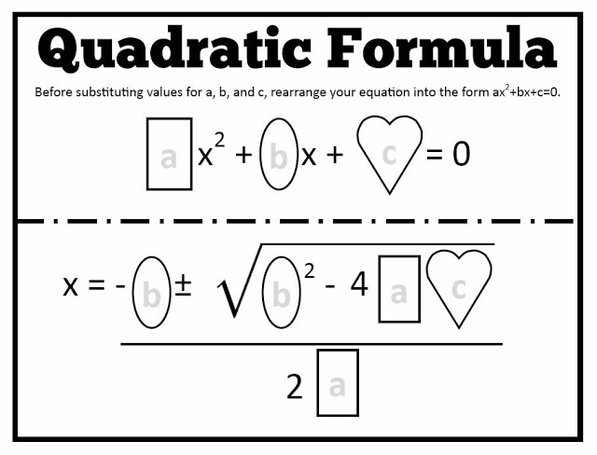 | Ex 1: Solve ${2x}^{2}-8x+1=0$  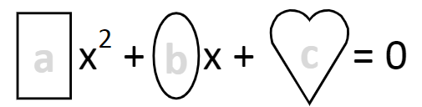  1  -8  2  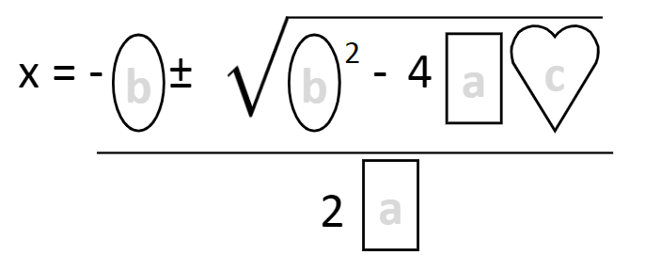  1  2  -8  -8  2  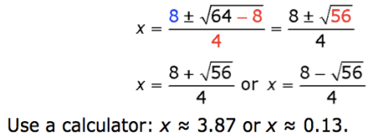

Solve the following using the quadratic formula.
1. $x^{2}+3x-7=0$ 2. $2x^{2}-5x+3=0$
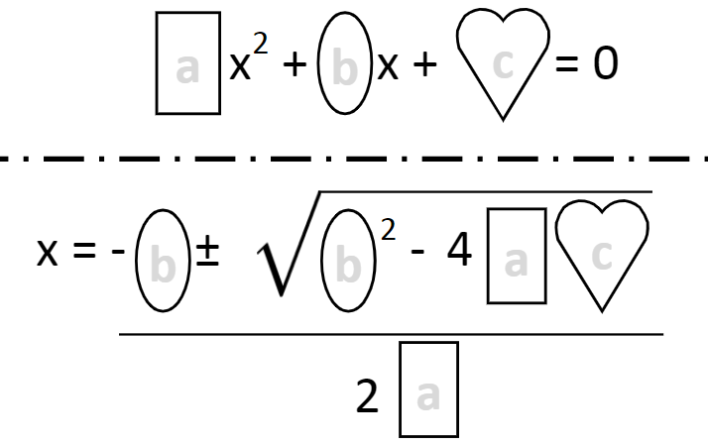
3. $x^{2}+7=0$ 4. ${2x}^{2}+4x+3=0$

5. $12x^{2}-12x+3=0$ 6. $-2x^{2}-5x+20=0$

7. $3x^{3}-4x=0$ 8. $x^{2}-4x+7=0$

